July 2004, No. 51

Deadline for contributions: 30.09.2004

Vienna NGO Committee on the Family
*Brunngasse 12/2, A-3100 St. Pölten, Austria
Phone: 43-2742-352718, Fax: 43-1-352718-5
Web: http://www.viennafamilycommittee.org
For contributions to ‘Families International’:
e-mail: famcom.vienna@utanet.at

From the Desk of the Chairperson

The Vienna NGO Committee on the Family organised a 10th International Seminar from May 6th to May 7th 2004 at the Vienna International Centre of the United Nations in Vienna, with the co-operation and support of the Austrian Federal Ministry for Social Security, Generations and Consumer Protection, entitled:

Civil Society Organisations Networking

- Interactive-Internet-Forums -

to celebrate the international Day of Families 2004 and to observe the 10th Anniversary of the International Year of the Family (IYF) in 2004.

This special issue of Families International is a Report on the Proceedings of the International Seminar. The programme of the seminar is also enclosed to guide you through the proceedings.

We hope that this report, with the input of professionals from academia, international organisations, representatives of government and civil society organisations, will increase the awareness of the possibilities and advantages of interactive dialogue, with the assistance of modern technology, for the well-being of families world-wide, and will welcome your comments and feed-back.
CIVIL SOCIETY
ORGANISATIONS
NETWORKING

10th INTERNATIONAL SEMINAR

PROCEEDINGS

Sincerely,

Peter Crowley
(Chairperson)

Table of Contents

Chairperson Peter Crowley

WELCOME & OPENING STATEMENT 5

Dr. Georg Mayer

CIVIL SOCIETY ORGANISATIONS NETWORKING
INTERACTIVE INTERNET FORUMS 7

Bob Huber

GENERATIONAL ISSUES AND INTEGRATION SECTION, DIVISION FOR SOCIAL POLICY 8

UNITED NATIONS NEW YORK

Prof. Mervyn Frost

Fragile Power: Global Civil Society Post 9/11 10

Peter Crowley/ Nina Mitts

Study on the Contributions of Civil Society Organisations

to the Well-being of Families since IYF 1994 17

Dr. Anna Home

Comparative Perspective of Contributions of

Civil Society Organisations in Central and Eastern European (CEEC)

and Eastern African Countries (EAC) to the Family Well-Being

of Families since 1994 19

Paul Reinker, Tobias Gersdorf

What do Interactive-Internet-Forums Offer? 22

Professor Jan van Dijk

THE NETWORK SOCIETY – THE PREVENTION OF STRUCTURAL INFORMATION
INEQUALITY 25

Digital Divide As A Complex And Dynamic Phenomenon 34

Michael Schwarz, Thomas Kloiber

REPORTS FROM THE WORKING GROUPS: 39

International Civil Society Organisations

Network of Central and Eastern European Countries (CEEC)

Peter Crowley

SUMMARY AND OUTLOOK BEYOND THE 10th ANNIVERSARY OF IYF 40

Bob Huber

CONCLUDING REMARKS 45

Civil Society Organisations Networking

Interactive-Internet-Forums

Thursday May 6th 2004 to Friday May 7th 2004

UNITED NATIONS

Vienna International Centre (VIC)
1400 Vienna
Austria



PROGRAMME
Thursday May 6th, 2004:
09:00 Registration
10:00 Peter Crowley, Chairperson of the Vienna NGO Committee on the Family
Welcome and Opening Statement
Ursula Haubner, State Secretary, Federal Ministry for Social Security,
Generations and Consumer Protection (requested)
Amr Ghaleb, Focal Point Programme on the Family United Nations, New York (requested)

10:30 Chair: Peter Crowley and Theresa Stourzh, Austrian Federal Ministry for Social Security, Generations and Consumer Protection (requested)
Prof. Mervyn Frost, London Centre of International Relations, Kings College London

Fragile Power: Global Civil Society Post 9/11
Questions from the floor and general discussion
11:30 Coffee Break
12:00 Nina Mitts, London Centre of International Relations, Kings College London
Peter Crowley, Vienna NGO Committee on the Family

Study on the Contributions of Civil Society Organisations to the Well-Being of Families since IYF 1994 - Initial Analysis
13:00 Lunch Break

14:30 Chair: Michael Schwarz and Angelika Schiebel,

Austrian Federal Ministry for Social Security, Generations and Consumer Protection
Paul Reinker, Tobias Gersdorf (Reinker & Gersdorf) Internet Company, Germany
What do Interactive-Internet-Forums Offer?

15:00 Working Groups (Phase I)
1. Network of Eastern African Countries (EAC)
2. Network of Central and Eastern European Countries (CEEC)
3. Network of International Non-Governmental Organisations Accredited with
the Economic and Social Council of the United Nations(ECOSOC)

16:30 Reports from the Working Groups to the Plenary

17:00 End of Session

19:30 Vienna City Hall, (Rathauskeller)
Reception by the City of Vienna for Participants of the Seminar

Friday May 7th, 2004

Chair: Peter Crowley and Günter Danhel
10:00 Prof. Jan A.G.M. van Dijk, University of Twente, The Netherlands

The Network Society – The Prevention of Structural Information Inequality
Questions from the floor and general discussion
11:00 Coffee Break

11:30 Working Groups, 1. EAC, 2. CEEC & 3. ECOSOC accredited (Phase II)
12:30 Lunch Break

14:00 Nasra Hassan, United Nations Office on Drugs and Crime,
Chief, Public Affairs and Interagency Branch

Bridging the Digital Gap with the Support of the United Nations

14.30 Working Groups,1. EAC, 2. CEEC, & 3. ECOSOC accredited (Phase III)

16:00 Report from the Working Groups to the Plenary

16:30 Peter Crowley, Chairperson of the Vienna NGO Committee on the Family
Summary and Outlook beyond the 10th Anniversary of IYF

17:00 End of Seminar

OPENING STATEMENT

Chairperson Peter Crowley

Distinguished Guests, Ladies and Gentlemen, Dear Colleagues,

On behalf of the Vienna NGO Committee on the Family, I would like to welcome you most sincerely, to our two day International Seminar entitled: Civil Society Organisations Networking – Interactive Internet Forums.

We meet to observe the 10th Anniversary of the International Year of the Family and to celebrate the International day of Families proclaimed by the United Nations.

We have been fortunate since our inception in 1985 to enjoy good relations and close cooperation with International Organisations, in particular with the United Nations. Allow me on your behalf to greet Bob Huber, Chief of the Generational Issues and Integration Section, of the Division for Social Policy and Development with the United Nations in New York and Ms Nasra Hassan, Chief of the Public Affairs and Interagency Branch of the United Nations Office on Drugs and Crime in Vienna.

We are also grateful for the support of governments of Member States of the United Nations, and we greatly appreciate the cooperation and support of the Austrian Federal Government for so many years now.

I would like to sincerely express the gratitude of the Committee to the Austrian Federal Government, in particular to the Federal Ministry of Social Security, Generations and Consumer Protection, which is cooperating with us in this seminar. State Secretary Ursula Haubner wished to be able to join us, but is prevented from doing so because of a commitment in the Austrian Parliament, and Dr. Georg Mayer will address the participants on behalf of the Austrian Government this morning.

We also have been fortunate to enjoy excellent relations with academic Institutions world-wide, and are happy to have Prof. Mervyn Frost from the London Centre of International Relations at Kings College London and Professor Jan van Dijk from the University of Twente in the Netherlands with us this week.

The inception of Civil Society is traced back to Europe, subsequent to a shift away from feudal to mercantile economies. We know that an essay on the history of Civil Society was written in 1767 by a Scotsman named Adam Fergusen, so Scotland has become associated with the cradle of Civil Society theory.

The notion that a third sector might exist, between the market and the state, got lost in the two sector view of the world and it is only in recent times, that the concept of civil society has re-awoken from its long hibernation, perhaps, in that cradle in Scotland. Indeed it is interesting to observe that the integration of civil society considerations into international development deliberations has concurred with the accelerated emergence of democracies from totalitarian regimes since the foundation of the United Nations in the middle of the last century. Involving civil society actors in the development process has become a major characteristic of international cooperation over recent years giving impetus to the notion of ‘development partnerships’ (Capacity.org 2001).

The High Level Panel on Civil Society which the Secretary-General constituted in 2003, under the chairmanship of the former president of Brazil, Fernando Enrique Cardoso, highlights the increasing importance of civil society institutions. As President Cardozo states: “The legitimacy of civil society organisations derives from what they do and not from what they represent or from any kind of external mandate. In the final analysis, they are what they do.”

In the run up to, and immediate aftermath, of the International Year of the Family in 1994 the focus was on (a) awareness building with regard to family issues, (b) a discussion on the rights of the family and (c) the search for a definition of family.

As Undersecretary-General José Antonio Ocampo stated in his statement to the 42nd Commission for Social Development in February 2004 on the 10th Anniversary of IYF “The family is an ancient institution, but it is also an evolving and changing institution. It is important to move away from a focus on what a family is, to a focus on what a family does.”

The English author, G.K. Chesterson, is quoted as saying, that people who make history, know little about history. If the same is true that we who network know little about networks or networking, then that alone would be a sufficient reason to meet here this week to see if we can change that situation.

The term ‘networking’ is traced back to the antropologist Barnes working in Norway in the early 1950s. He envisaged a fishing trawler net, where the knots, also known as nodes or vertices, which represent humans or organisations, and the ropelines, also called edges, or sets of lines, connect the relationship between them. In the Internet e.g. the knots would be hubs and the links the ropelines. The networking concept is a bridge or hinge between the microanalytical approach, which has the individual in focus and the macrosociological approach, which tends to deal with trends and general concepts.

Barabási studied 325.000 web sites in 1999, which was then only a portion of all web sites world-wide. Most sites had only two or three links to other sites. This is in stark contrast to the estimated 100 million e-mail users world-wide, with their multiple links through their address data base. So there is scope for development in the area of linkage, to facilitate networks reaching out to others and to benefit from a cross pollination. Building links in a two way process could become a priority, especially for civil society organisations.

Mindful of the focus on doing, rather than just deliberating, the Vienna NGO Committee on the Family, which was founded in 1985, has focused its endeavours on ‘institution building’ and has set up a number of interactive-Internet-forums for civil society organisations. One forum is concentrated in Eastern African countries, incorporating at present 84 organisations in six countries. A second forum is focused on Central and Eastern European Countries, incorporating 50 organisations. A third forum composes 27 ECOSOC accredited international NGOs.

Through the interactive facilities of these institution-building projects these organisations can exchange information and expertise to tackle the substantive issues confronting them, such as e.g. education, health promotion, HIV/Aids, water supply, to mention but a few, as well as seeking assistance from sources, using the links provided, to other relevant international organisations, helping to transfer information into ‘ecologies’ of knowledge and build out of virtual networks of practice, sustainable communities of shared disposition (Brown & Duguid 2002).

Over 100 NGOs who replied to a world-wide survey hosted by the King Baudouin Foundation, “rate opportunities for networking and building effective strategic alliances with other organisations as having significant potential for increasing the capacity of their organisations.” These Interactive Internet Forums can further encourage civil society organisations to establish partnerships with Governments and international organisations to, inter alia, facilitate local and global capacity building and enable civil society organisations to become agents and facilitators of social change and ultimately enhance social justice.

As the United Nations Secretary-General stated at the Millennium Forum in May 2000, convened to reflect on the relationship between civil society organisations, governments and the United Nations, “Communications technology has enabled you (NGOs) to connect and interact across almost all frontiers. You have understood that problems without passports require blueprints without borders.[…] You can help us bridge the digital divide, which at present is excluding whole regions from the benefits of information technology. […] By making the connection between the local and the global, you will make a difference more widely.”

The Secretary-General further said at that Forum; “Today, I am asking you NGOs to be both leaders and partners: where necessary, to lead and inspire Governments to live up to your ideals; where appropriate, to work with Governments to achieve their goals.[...] By working through consensus rather than confrontation, you will be involved more closely.” (K. Annan, Millennium Forum United Nations 2000).

The 1948 Universal Declaration of Human Rights declared that everyone has the right to freedom of expression and the right to ‘receive and impart information and ideas through any media and regardless of frontiers’. The Internet has become a vitally important area for civil society, because it has allowed the voice of grass-roots organisations, lacking strong financial resources, to be heard.

Oneworld.org is the largest civil society ‘portal’ on the Internet set up in 1995; by two journalists with 22 organisations, specialising in human rights, and now has over 1500 partner organisations and attracts over a million page viewers a month in over 90 countries.

I wish our deliberations, with the input of such distinguished presenters, and contributions and questions of participants from the floor, as well as their contributions to the workshops, over the next two days, to be challenging and constructive and above all, to see us depart tomorrow being all the richer for the experience.

Civil Society Organisations Networking

InteraCtive Internet Forums

Dr. Georg Mayer,

Austrian Federal Ministry for Social Security, Generations and Consumer Protection

Ladies and Gentlemen!
First of all Excuse Secretary of State Ms Ursula Haubner. She is in an important meeting in the Austrian parliament!
It is a pleasure for me to welcome you all here at the Conference. It is a great honour for us to host this conference with distinguished participants from many countries.
In 2004 the world celebrates the tenth anniversary of the International Year of the Family. Family is always a topical issue and this year it ranks high on the agendas worldwide. On the occasion of the tenth anniversary of the International Year of the Family in 1994, it is important for us to have you all here.
Austria has been highly active in incorporating family policies as integral part of the entire range of political fields in content and structure. Tasks and duties of families do not diminish; the number of responsibilities they face is even growing. Therefore, we have to ensure the follow-up of our family-related efforts at all levels in order to continue and benefit from families’ potentials. In order to achieve this goal the international community of states should reaffirm family policies as an important issue and develop them further.
From Austria’s point of view, civil society organisations (CSO´s) make an important and highly necessary contribution to the development of global human capital represented by the families.
Just like ten years ago, here in Austria a national committee paves the way for future-oriented family policies. In a common dialogue including the federal, provincial and municipal governments as well as the civil society, experts focus their discussions and deliberations on the current and upcoming challenges in family policies in 10 different working groups.
These working groups include more than 500 men and women, experts from fields such as politics, administration, business and the civil society. This form of co-operation is a good example of our integrated approach to family policies embracing all actors and „stakeholders“ of the family issue, which has been incorporated as an integral part throughout the entire number of political fields.
I don’t want to keep you of any longer from your work right now. I hope that you all will also enjoy the special Viennese atmosphere this city really has and end this active and fruitful day at one of these comfortable and homely places of which Vienna has a lot of to show. I very much look forward to see the results of your discussion and wish you all an interesting and productive period of work at this conference.

Generational Issues and Integration Section, Division for Social Policy

Bob Huber

Chief, Generational Issues and Integration Section, Division for Social Policy and Development, United Nations, New York

On behalf of Mr. Johan Schölvinck, Director of the Division for Social Policy and Development of the United Nations Department of Economic and Social Affairs, I am pleased to take part in the opening of this International Seminar in observance of the tenth anniversary of the International Year of the Family.

We are celebrating the tenth anniversary of the International Year of the Family, but next week – on May 15th – we will also observe the International Day of Families. At the intergovernmental level, this confusion of terminology is a reflection of long-standing political divisions that have had the unfortunate effect of distracting attention from the very real issues and concerns that affect families all over the world.

And so I wish to start my remarks by considering what we mean by family. Each of us belongs to a family, and each of us has his or her own very personal understanding of what a family is. There is no single definition of a family, and yet much of the discussion about “family” seems mired in an attempt to find a definition. I believe it is more important to think about what a family does: the caring, support and nurturing that families provide for their members. A family enjoys a sense of identity, responsibility and affiliation, even when its individual members may not be living together under one roof. As individuals we need to receive this support, and we need to provide it to other members of our family.

So when we think about “strengthening families”, I suggest that we should not focus on preserving a particular type of family, but on finding ways to help all families to carry out their social roles and functions, and to respond to emerging challenges and changes in society. Efforts to “strengthen the family” should be efforts to strengthen and support the functions that families perform.

As we mark the tenth anniversary of the International Year of the Family, it is important to recognize one of the most far-reaching achievements of the Year, which is the greater awareness of what families contribute to economic development and social progress in societies all over the world. This “family perspective” is becoming an important factor for development, a fact that is increasingly reflected in national development plans and in programmes of economic and technical cooperation of organizations of the United Nations system. The formulation of family policies must take place within the framework of overall socio-economic development strategies but, more than this, those development strategies must also take into consideration the very vital role played by families. Thus, it is very important for policy makers to undertake a diagnosis of the situation and needs of families before they elaborate national developmental policies and specific programmes.

A great deal of attention has been given lately to “mainstreaming”. Nowadays, every group and interest is being “mainstreamed”, and the family is no exception. I would suggest, however, that in the case of families, this effort is somewhat inappropriate. Mainstreaming is meant for groups that are peripheral or marginalized. The family, by virtue of its function as the basic unit of society, is not marginalized but central to, and already in the mainstream of, society. The family may be undergoing change and facing pressures to fulfill its care-giving functions, but it is not marginal to any person’s life. The problem is that, often, the centrality of family has escaped the attention of policymakers. They have therefore given insufficient thought to the contributions families make to the well being of their members, and paid insufficient attention to how policies affect families. The problem is not the family or what it does; the problem is that policy makers and planners have ignored the family. Policies and programmes that fail to consider families are not likely to offer the necessary support families need. The solution is not “mainstreaming the family”, but “integrating a family perspective in policy making”. In other words, ensuring that policy makers take into account the needs of families and consider how their actions will assist families or hinder them from meeting their needs.

Also, mainstreaming – or integrating a family perspective – is not a way to make the family issue disappear. Integrating family is not an alternative to, or substitute for, a programme of advocacy and technical support. It is important to continue to provide expertise and appropriate technical support on family issues. Any efforts at integration must be accompanied by continued advocacy of family issues, leading to a two-tier strategy that combines integration with continued advocacy.

The United Nations family programme will continue to utilize this two-tiered approach. Shortly, Mr. Amr Ghaleb, the focal point on family, will retire after long service with the United Nations. When he retires, a new focal point on family will be appointed to take his place. The activities of the family programme will continue in the years ahead, following the observance of the tenth anniversary. This is a reflection of the continuing importance given to families by the United Nations.

The activities of the United Nations family programme since 1994 have focused on five major themes:

(a) approaches to family policy development;
(b) technology and its impact on the family;
(c) parental roles and intra-familial support systems;
(d) statistics and indicators for family well-being; and
(e) HIV/AIDS and its impact on families.
These themes were supported by seven types of activities:

(a) standard setting;
(b) exchange of experiences and expertise;
(c) research;
(d) technical cooperation;
(e) promotion and advocacy;
(f) inter-agency cooperation; and
(g) interaction with civil society.

Let me expand a bit on this last point. For many years, even long before the observance of the International Year of the Family, the United Nations has considered civil society organizations to be strategic partners in both its own work, and in the activities of national and local governments. Indeed, civil society organizations provide a vital resource for participation and for development. These organizations represent the self-organization of societies, as individuals join together in a vast array of groupings and networks. We are grateful for the support and contribution these organizations have made and we look forward to continued collaboration, at the local, national, and international levels, in the future.

The way ahead is clear. Families, in whatever form people choose to consider them, will continue to be essential for human well being. Policies and programmes will increasingly recognize this role and seek to support it. A successful family programme, whether at the national or international level, will require both integration of a family perspective and advocacy of family issues. The United Nations will continue to fulfill this function at the international level, and will promote it at the national level as well. This is the commitment the Division for Social Policy and Development has made and will keep in the years to come. Thank you.

FRAGILE POWER: GLOBAL CIVIL SOCIETY POST 9/11

Mervyn Frost
Centre for International Relations
King’s College London

It is a great pleasure for me to address you this morning. The work which the Vienna NGO Committee on the Family does and the related work done by those of you who have set up the Interactive-Internet-Forums, is important work which brings benefits to many people around the world. It brings benefits in public education, it opens avenues for debate, it enables participation, it furthers transparency, and helps hold public actors to account. Importantly, in the long run the IIF will generate power with which to protect the interests of the family wherever they are threatened.
The work done by the Committee and the Forums is located and made possible within a global social practice. I am hoping that I can make a small contribution to what you do by putting forward an analysis of the social practice within which the Interactive-Network-Forums operate. In particular, I wish to examine that part of our global practice known as global civil society.
Global civil society is the social formation which makes the existence of the Interactive-Internet-Forums possible. The IIF depends on a foundational facilitating social practice or structure. Under certain other social formations you would not be able to do what you do. For example, if there was an authoritarian or totalitarian global state your networking activities would not get far. In that kind of social practice if they took place at all they would have to be secret and undercover. Instead, in the world in which we live today, we regard ourselves as entitled to set up NGOs which deal with issues such as the family. Were we to be denied the opportunity to do this, we would feel ourselves to have been wronged.
In my short talk this morning I want to examine global civil society as it exists today. I shall outline its main features, drawing your attention to its great strengths and pointing to the threats which it faces. In particular I wish to draw your attention to the opportunities and dangers which face global civil society in the aftermath of the events of 11th September 2001. In offering my analysis this morning I shall be drawing your attention to several ethical issues. For it is the case that all social analysis requires of us that we engage with ethical matters.

What is Global Civil Society?
There is a complex and turgid literature which engages with this question. There are those who see civil society as a layer of voluntary institutions which exist between the market and the system of states. Civil society, it is said, forms a buffer between these massive powers. An alternative view, strongly propounded by Karl Marx, holds that civil society includes the market. He analyzed the ways in which civil society threatened traditional modes of doing politics within states. On his view the growth of civil society has had the unfortunate result of relocating matters which should be in the public political realm, into the private domain. Any of the major decisions which affect our lives are made by actors invisible to us and not accountable to us. Hegel had yet a different view. He put forward a view which showed civil society to be a social formation on which the edifice of the state was built. Happily we have too little time today to go into the details of these often arid disputes. I am simply going to put forward a definition of global civil society which I think will be useful for my purposes.
Global civil society consists of all those people (like us) worldwide who consider themselves to be the holders of first-generation rights and who recognize everyone else as having an equal set of basic rights. These are the people who have set up the NGO’s that form the backbone of this conference. At bedrock the defining feature of civil society is that it consists of a set of people who speak a common language of individual rights. It is a society defined by the language its members speak, it is defined by a discourse. In this society by speaking a certain language, we grant to one another an important ethical standing which is that of being a civilian. Civil society consists of civilians, that is, rights holders.
The people gathered in this audience today are members of global civil society. I have no doubt that everyone here considers him or herself to be the holder of, at least, a set of first-generation rights. One of the things you say about yourselves is, “I have certain inalienable rights.” I am sure that none of you consider yourselves to be the legitimately owned slave of someone else. The rights which you consider yourselves to have include at least the following: Rights of the person, such as the right not to be killed, tortured, assaulted, the right to freedom of speech, association, movement, conscience, academic freedom, and, of course, the right to own, buy, and sell property.
This global civil society, defined as the society of those who say of themselves that they have fundamental human rights, has certain remarkable features to which I wish to draw your attention.
First, civil society is borderless. We do not consider ourselves to have the rights we claim for ourselves merely because we live in a certain territory or state. We consider that our rights may be claimed by us wherever we find ourselves. In some parts of the world it may be the case that there is a strong state at hand to protect our rights. In other parts of the world there may be weaker states or failed states or, indeed, no states at all in place to protect our liberties. Yet, in such cases, we shall still say that we have rights, even if they are at risk. What I wish to stress here is that states do not give us our rights. They might often abuse our rights, but the rights do not originate from the state. They are not gifts from the state.
Second, civil society has no membership committee which determines who may or may not become a member. This is because civil society has no government which can specify who is or is not permitted to be a member. What this means is that civil society is open to all comers. Admission is not reserved. It is not discriminatory along any of the normal measures of discrimination like gender, race, religion or ethnicity. One becomes a member simply by learning to speak the language of rights. People who have not traditionally thought of themselves as rights holders can become participants in global civil society by learning how to claim rights for themselves and to recognize them in others. Worldwide more and more people are becoming members in this way - they are learning the language of rights.
Third, civil society has no central government, and thus has no lawmaking, law-implementing, or judicial institutions. Civil society is not the state or the system of states. It follows then that civil society does not make policies. It consists of individual rights holders. Civil society itself does nothing. It is not a collective actor.
Fourth, because civil society has no central government and because it has no specified territory it is difficult to conquer. There is no heartland which the enemy of civil society could take. There is no place on which to raise the flag of victory. At best, the enemies of civil society can harm individual members. Another way to put this, is to say that the enemies of civil society can only harm portions of the total fabric of global civil society. There is no Bastille to be stormed.
As I have mentioned those of us who participate in civil society are civilians. Right conduct in the society requires civilians to treat one another in a civil way. Civil society is a domain for the conduct of civilized politics.
If we apply the above to the organizations involved in today’s meeting we may say that all the NGOs involved here today arose when civilians made agreements amongst themselves to set up organizations directed towards serving the family. Crucially these organizations are not creatures of the state. That is why they are called “Non governmental organizations.” The organizations which comprise the Interactive Internet Network are not the creatures of any single state or any set of state based set of organizations.

The Power of Civil Society
From the foregoing I hope that it is self-evident that civil society does not have the same kind of power that states have. States are collective actors. The power of states stems from pooled resources under the control of a public authority. The taxes which we pay to states are transformed into various kinds of power including military power.
In civil society things are different. There are all sorts of power generated in global civil society, these are the outcome of the pooling of resources, but not under a public sovereign authority. There are multiple nodes of power which are in a constant state of flux. What power there is derives from the actions of individual rights holders. In civil society civilians come together in thousands of different groupings. These form locations of power. The organizations in this meeting today are examples of units of power built up in this way. Whatever power gets made in civil society, it comes about through individual action by civilians. Each civilian has to make a judgement about what it is right to do and about how best to advance his or her interests. Each has to decide what kind of power he/she is interested in constructing.
Contrast this with what happens in states. In states, a government which consists of a handful of people, makes decisions for millions of citizens. The handful decides for the millions on great issues of war and peace, education, welfare, housing, pensions and so on. In civil society instead of the few deciding for the many, we have the many deciding each for him or herself, what is to be done. The diversity of points of view and the huge range of possible courses of action open to civilians is the latent power located in civil society. Problems which arise in civil society are confronted, not by the limited intellectual resources of a President X or President Y and their obsessions about weapons of mass destruction, for example, but are confronted by the independent thought of millions of civilians. There is an in-built experimental element in civil society. Different groups of civilians can test out different ways of doing things and compare results along the way. Where some course of action does not work the watchful eyes of millions of civilians will soon bring this to public attention.
Again there is a contrast here with what happens within states. Within states governments have strong incentives to deny any mistakes they might make.
The power accumulated in civil society may take many forms. It might be material power (also known as economic power). It might take the form of epistemic communities who come together to accumulate and use scientific knowledge and the power it brings. Another form of power comes into being when people congregate around a set of beliefs to form a church. There are any number of cultural forms of power which emerge when people unite around ideas of nationhood, ethnic identity, or social class. Then there are organizations which focus on a single issue like the family.
Once nodes of power start forming within civil society, inequalities soon emerge. Some get to wield more power than others. However, no one or group wields an authoritative monopoly of power. There are always new opportunities available to civilians to associate with one another to form new loci of power and influence.
More and more people are entering into global civil society by learning and accepting the discourse on individual human rights. As participants in this society, as civilians, they are setting up thousands of organizations for the advancement of this or that purpose. All writers on civil society are agreed that the number of civil society organizations is expanding. Wherever in the world individuals understand themselves to be players in global civil society they are making use of their rights to form more associations directed to solving more problems than ever before. The central point here is that this expansion is happening because it has been made possible by the existence of global civil society. The authority structure of previous social regimes was not conducive to the creation of lobbies, pressure groups, NGOs, social movements, and so on. Modern civil society, in contrast, has acted as a huge encouragement towards this kind of creative effort.
It is crucial to notice that the groups formed in the space of global civil society are in many ways not respectful of traditional boundaries. More and more transnational organizations are being formed. The organizations present here today exemplify this trend.
It is also important to notice that many of the organizations found in civil society are not themselves organized along democratic lines. Many of them evince a democratic deficit.

The Ethical Dimensions of Civil Society
Global civil society is a domain of freedom. In it individuals are constituted as rights holders -- as free people. This is in sharp contrast to the ways in which we were constituted in previous forms of society. For example, in absolute monarchies ordinary men and women were constituted as subjects (in Swaziland they still are); and under tribal rule men and women were and are constituted as members of the tribe under the authority of a chief. In most pre-modern social practices there was an hierarchical structure. In contrast global civil society as I have defined it, has an organizing principle -- that of equality. Here no one is set up as the chief, the ruler, or the leader, instead, in civil society the members recognize one another as holders of equal sets of basic liberties. The implications of this are very important for our meeting today. In civil society anyone may decide to set up an organization to promote, for example, the well being of families. This is not the prerogative of heads of families, of Kings, of chiefs, or of any other privileged class of persons.
In case you think that I am waxing utopian about the character of civil society, let me admit that there are deep-seated ethical problems inherent in civil society. In civil society we are in perpetual competition with one another, we often find ourselves to be alienated and alone, and the huge power differentials soon emerge as the result of an endless series of interactions between rights holders. Some get rich, others end up poor. We have found ways of solving these problems. The most dramatic of which is through the construction of democratic states. In these we constitute one another as citizens and by so doing we re-establish a form of equality between ourselves. In this lecture I cannot go into the details of the democratic state within the system of such states. For my present purpose all I need to show is that democratic states have to be built on the basis of a civil society. Citizenship in a state which did not allow and protect a civil society would not be worth a candle. We have had ample evidence of that in the former Soviet Union.
It follows from the above, then, that if we value the status we enjoy in global civil society, both for what it can deliver in material terms and for ethical reasons, then we have an interest in defending it from any threats which might confront it. Are they any? If so, what are they?

Threats to Global Civil Society
Global civil society faces threats from above, below, and from within. Let us consider each of these in turn.
The threat from is often posed by the state. There are all kinds of states which threaten the liberties we enjoy in civil society. For example, authoritarian states, totalitarian states and absolute monarchies are institutional forms which regularly deny to those who live in them their basic rights. The regime that existed in the Soviet Union did not protect civil society in its territory. Similarly, the minority rule arrangements in South Africa under apartheid eroded the basic structure of civil society. More difficult are those cases where the state is democratic. We generally believe, and the governments of such states tell us, that such states protect our basic rights rather than deny them. In many cases this is true. However, this is not always the case. Even the governments of democratic states may come to pose a threat to basic liberties. Ironically, the threat which they pose is often introduced to us as a policy designed to protect basic liberties. This manoeuvre, eroding liberty to protect liberty, is a pressing issue today in the wake of the 9/11 events. Governments throughout the democratic world are being tempted to introduce legislation which effectively gives them more power over us and limits our liberty. This is done by extending the powers of the police, the security agencies, and the military. Governments are granting their agencies the right to put civilians under surveillance in ways which offend the most elementary notions of privacy. The methods include, telephone tapping, permitting their agencies to gain internet access to our private computers, to compelling banks to reveal details of private personal accounts, to the use of new biometric identification techniques that keep track of where we are, what we do, who we meet and so on.
In the name of defending freedom states are extending their right to censor information. In particular they are ever more inclined to curtail the ways wars are reported. States are extending their right to detain people for indefinite periods in order to question them about their supposedly involvement in “terrorist” activities. One can foresee a time when churches, not only Islamic ones, will be legally required to reveal details of the people who worship in them to the governments of states. Airlines are already compelled to play a policing role with regard to the passengers who fly on their planes. I can anticipate a time when the boundaries of the family will be breached in the name of security and the war against terror.
It does not take too much imagination to see how the increased powers of the state over civil society will impact on organizations such as yours. Organizations of all kinds will come under scrutiny. The movements and communications of their members will be monitored. The their records will be examined. The internet activity which emanates from them will be under constant observation. The authorities may soon make use of your organizations and networks to detect people who have a certain profile which identifies them as people likely to become involved in terrorist activities. Confidential relationships which have traditionally held between professionals and clients may be subject to scrutiny by state agencies.
A different set of threats is posed to global civil society from below. Mary Kaldor has offered as an analysis of what she calls “New Wars” in which she identifies enemies of civil society. She examines the wars which took place in Yugoslavia since the end of the Cold War. These have often been portrayed as inter ethnic wars, but she challenges this. She identifies the groups which caused the carnage in Bosnia, Kosovo, and still threaten to do so in Montenegro, as being between those modern people committed to defending civil society and those who are opposed to it. The latter group consists of a combination of criminals, warlords, and proto-nationalist leaders who make use of the language of nationalism to justify their essentially self enriching activities. The essential feature of such people and groups is that they do not respect the rights of civilians in global civil society. Such people not only pose a threat locally, but through their links with the global criminal networks, they threaten global civil society as a whole.
Another group that poses just such a threat to civil society globally is of course Al Qaeda. Although its activity often seems to be primarily anti American, it poses a threat that stretches much wider than this. There is a real sense in which people everywhere fear an attack from global terrorists. The fear of terrorism is now quite properly understood to be a global one. There is no reason to suppose that Vienna is any safer than other places.
There is an interesting symmetry here between the dispersed and open nature of global civil society, on the one hand, and the dispersed and open nature of the threat posed to it by organizations such as Al Qaeda, on the other. There is an irony, too, in this threat. For, Al Qaeda, makes use of the very facilities created by global civil society in order to generate its own power. It uses the freedoms available to it in global civil society to generate a threat that seeks to undermine it. Al Qaeda operatives make use of all the apparatuses of civil society, mobile phones, the internet, easy travel within Schengen countries, and the free mobility made possible by a global civil society. Most importantly its members make use of their legitimate rights in order to promote their nefarious ends; they make use of their civil liberties to organize their deadly campaigns.

Beyond the threat from above posed by the state (and states) and the threat from below posed by organizations such as Al Qaeda, there are specific threats from within global civil society which we need to consider. There are any number of organizations which make use of civilian freedoms to promote policies designed to undermine them. For example, organizations which promote racist goals, organizations which seek to limit the free movement of people, organizations which seek to undermine the rights of women, or the rights of children, international criminal networks and many others, provide examples of these. Here again, as with Al Qaeda, we can see the ways in which those who promote such organizations make use of all the facilities offered to them in civil society while actively seeking to undermine it.
It is easy to see how the threats I have identified above present an organization such as this one with problems. In order for it to flourish it needs an open, vibrant, and well protected public space in which to conduct its activities. The politics with which it engages requires this space. Overbearing states, the lawless warlords, and subversive insiders, all threaten the good work which it does. In order for this organization and this network to continue in business, the civil society which has made it possible needs to be secured? How might this be done?

Defending Civil Society
How might we, civilians in global civil society, defend our practice from the threats identified above?
Before discussing particular defences, let me mention a general problem. The defence of global civil society has to be quite different from what is involved in defending a territorial state or collection of such states. In traditional interstate politics securing a territory and the government of the territory, is at least conceptually straightforward. What is required is that the enemy is repelled and kept at bay. The border to be defended, and the enemy to be defeated, are all clearly identified. What is to count as victory is clear to all - friend and foe alike.
In the case of global civil society its defence is not like this. For it has no specific territory and no specific borders to defend. It is not located in any determinate place as distinct from other places. As I mentioned above it is an open society which consists of those people who claim rights for themselves and respect them in others. The extent of the society is determined by the participants, not by some territorial boundary. Where its members are located is irrelevant to the legitimacy of the claims which they make on one another. Civilians recognize one another’s status wherever they find themselves.
In order to make it clear what kind of entity civil society is, and, how one might go about defending it, I would like to introduce an analogy. Civil society is analogous to the practice of speaking a language such as English (or German or French or any other natural language). The practice of English speakers is worldwide and open. One joins it, by learning how to speak English. The enemies of the practice include all actors that make speaking English impossible or difficult. In like manner, the enemies of global civil society consist of all those actors which make claiming and exercising rights difficult for civilians. What has to be defended is the ability and opportunity to claim the rights constitutive of civil society. What has to be understood here is that what is being defended is a way of doing things, not a territory, a battlefield, or a building. The object to be defended is a way of relating to ones fellow humans. What has to be defended are the rights of civilians and what has to be opposed are the actions of those who abuse civilian rights.
Within states we have a common name for rights abusers, we call them criminals. Within states we have a complex apparatus for preventing crime and for punishing and rehabilitating criminals. I wish to suggest with as much force as I can muster that there is good reason for calling those who abuse civilians in civil society criminals rather than enemies. The difference in word is important. A criminal is a member of our society who has done wrong and who deserves to be caught and punished. In sharp contrast, enemies are outsiders who have unjustifiably crossed a border and must be repulsed. They need to be defeated, even killed. If global civil society has no territory and its members are to be found everywhere, then it follows that there is no outside to which we can expel the supposed “enemies of civil society”. Those who threaten it are best understood as insider-criminals. Indeed, it is a constitutive rule of global civil society that all civilians are committed to treating everyone as members of the civilian society, even those who have not yet managed to learn the language of rights and including those who oppose civil society. Given this constitutive rule we can hardly treat wrongdoers as outsider/enemies to be defeated. Instead, we must understand the wrongdoers as civilians who have not yet learned civility.
In order to defend the rights we enjoy as civilians there are any number of measures we may deploy. These include all the sophisticated apparatuses provided to us by our states in the system of states. These include police forces, judiciaries, military forces, and other formal mechanisms available to government. Another instrument which we might use are those provided for us by international organizations. Here I have in mind the International Criminal Court and the various human rights courts and commissions, amongst others.
Beyond these we can also use any number of private organizations. These might be particularly pertinent in those areas of global civil society where there is no operative state. Here the case might be made for the use of private security companies. Of course, we would have to take measures to make sure that these companies did not themselves become criminals.
At the limit, we may from time to time have to resort to self-help to fight those criminals who threaten our rights as civilians. This we would have to do in those circumstances where there was no state to help us, or where the state itself had turned into an enemy of civil society. This happened in South Africa, in the Soviet Union and in many other places.
For those seeking to defend global civil society the ultimate goal is to prevent criminal activity which undermines the rights of civilians. A component of this is to transform the criminal into a rights respecting civilian. This requires inducing him or her to respect other people’s rights and to demand such respect for him or herself. What is sought is a form of mutual recognition. In order to bring this about only certain means are available to us.

When what is sought is that form of mutual recognition which holds between those who see one another as the holders of equal sets of basic human rights, the means available for bringing this about are severely constrained. Force is not likely to be successful. Pointing a gun at someone and saying “Recognize me as your equal” will not succeed. This is a lesson which is being learnt by the “Coalition” in Iraq at the moment. Directing an army at the people does not induce them to recognize one another as citizens in a democracy or as civilians in civil society.
What is called for to bring about mutual recognition as rights holders is some form of education. At the very least the target of concern has to be treated as a rights holder. What is being sought is the setting up of a certain kind of relationship between the criminal and the rest of us in the practice. Establishing relationships of mutual recognition is a particularly complex business. It involves at least the following: Dialogue with the party with whom reciprocal recognition is sought; the commitment of certain material resources to fostering the relationship; an openness on the part of both parties to establishing a new relationship; and a refraining from any kind of activities which would demonstrate bad faith by either of the parties. A good example of what I’m getting at here may be seen in the recent expansion of the EU. In order for the relationships of mutual recognition to work both the old member states and the new ones have had to take the risk that the other parties will accord to them the recognition due to them. There has been dialogue, there has been a commitment of resources, and so on. The relationship has not emerged as a result of the use of force.
Whether the threat to global civil society comes from above, the below, or within, in each case the counter to such threats will have to consist of two parts.
First, the criminal has to be prevented from perpetuating his/her wrongdoing. In the case of a so called “terrorist” this might require the use of force.
Second, in undertaking the first step and in the follow up the protection agency must show itself to be serious about the norms embedded in the practice. The protector must demonstrate in everything done that he/she is not himself/herself a criminal who does not respect civilian rights. What is required here is that the protector (whether it be an individual a group or a state), must demonstrate his/her/its own standing as a civilian in global civil society. What has to be shown is that civil society is not being destroyed in the process of protecting it.
Here is a short description of some ways in which we might use and support states that seek to protect global civil society from threats from above, that is, from threats posed to it by rogue states. The defences might include the use of diplomacy, conditionalities, threats of sanctions, sanctions, and at the limit a proportional amount of force to stop the rights abuse taking place. To avoid any suggestion that such acts are in pursuit of self interest it is important that international actors act in concert, in a multilateral way, making use of international organizations where they can.
Similarly, if our own state abuses our civilian rights then we may seek to protect these through a number of graduated actions. The menu of actions open to us starts with public criticism, and then moves on to, public demonstrations, party political action, opposition through the electoral system, passive resistance, civil disobedience, and, at the limit, the use of proportional force.
The central point in all this is that in our attempts to protect global civil society, the society of rights holders, we must at every point demonstrate, in the means that we use, our commitment to human rights. For it is only if we demonstrate this commitment, that it will be possible to establish the kinds of relationships between ourselves and others which are constitutive of civil society.

Conclusions
In this short talk I have sought to highlight the following: The work of the Interactive Internet Forum is made possible by the existence of a global system civil society of individual rights holders. I highlighted the main features of this society which are that it is borderless, without central government, and open to all. In it power is dispersed and dynamic. The society faces particular threats from states, even democratic ones, and from a number of rights threatening groups at the sub state level. Typical of these is Al Qaeda. I explored and number of defences open to civilians against such threats. At every point I sought to highlight the fact that in defending civil society every effort must be made not to destroy key elements of the society in the name of defending it. Building a society in which rights holders recognize one another as such, is often a slow and painstaking business. It is an ongoing task and cannot be achieved with a silver bullet, a quick fix, or a war against terror. The defence of civil society is like police work; it has to be done well and it has to be done all the time.

WORKS CITED

Anheier, H., M Glasisus, and M. Kaldor, eds. The Global Civil Society Yearbook. Oxford: Oxford University Press,
2002.
Frost, Mervyn. Constituting Human Rights:Global Civil Society and the Society of Democratic States. London:
Routledge, 2002.
Hegel, G.W.F. Hegel’s Philosophy of Right. T.M.Knox. Oxford: Oxford University Press, 1973.
Kaldor, Mary. New and Old Wars:Organized Violence in a Global Era. Cambridge: Polity Press, 1998.
Kegley, Charles W., and Eugene R. Wittkopf. World Politics. Boston and New York: Bedford/St Martin’s, 2001.
Rosenberg, Justin. The Empire of Civil Society. London: Verso, 1994.
Walzer, Michael, ed. Toward a Global Civil Society. Oxford: Berghan Books, 1995.

Study on the Contributions of Civil Society Organisations to the Well-being of Families since IYF 1994

Peter Crowley, Nina Mitts

At the 4th consultative meeting, in a series, convened by the Programme on the Family within the Department of Economic and Social Affairs of the United Nations (DESA) in 2002 in New York with international and regional non-governmental organisations “it was agreed to prepare a study, under the chairmanship of the Vienna NGO Committee on the Family, on the positive contributions of civil society to the well-being of families since 1994. The study will be submitted to the General Assembly in 2004, at its fifty-ninth session”. (cf. Report of the Secretary-General of the United Nations to the General Assembly - A/57/139, 2002).

A concept was laid out by the Chairperson of the Committee to gather data for this study by setting up an interactive-Internet-forum, at: www.10yearsIYF.org with the professional advice of our Internet company, inviting ECOSOC accredited INGOs who regard themselves, in part or in their entirety, as family-oriented, to participate. 72 International Organisations have replied positively to the inviation to join the Forum and to date 27 INGOs from over 15 countries in all 5 continents have entered data on their contributions to the well-being of families. An analysis of this data has been carried out by Nina Mitts who studied with Prof. Mervyn Frost of the London Centre of International Relations, Kings College London.

Descriptive Analysis

[Abridged Summary – Complete text available at www.10yearsIYF.org and published in ‘Documenting Contributions of Civil Society Organisations to the Well-Being of Families’ ]

Nina Mitts states in summary that;

“While the state continues to play an important role in family policy and its well-being, the role of governments in the advancement of family well-being has been transformed by the growth of civil society organisations (CSOs) globally. Scholte defines global civil society as “civic activity that addresses transworld issues; involves transborder communications; has global organisation; and works on a premise of supraterritorial solidarity.” Civil society organizations have representations in many different countries, come in all shapes and sizes, and range from single issue campaign groups, to volunteer-run networks, or large-scale charities with hundreds of staff. They have the ability to organize globally, with a driving effort to put pressure on national governments, corporations, and international organizations to meet community needs, defend interests or promote new policies. Some have no identifiable location and are of a virtual character. CSOs have begun to band together in common purpose, particular issues, and with efforts to “build linkages among citizen groups”.

Primarily, CSOs are dedicated to improving their communities and societies. Such collective endeavours have always existed in some form or another in every society owing to the endurance of civil minded individuals, but have fortunately gained strength and visibility through UN conferences, starting in with the 1992 Earth Summit in Rio, but also through others such as the 1993 World Conference on Human Rights in Vienna and the 1995 Beijing Fourth World Conference on Women. Family NGOs have been facilitated through all of these UN efforts, but also through specific conferences and programmes geared toward the family, such as the “International Year of the Family” in 1994 and subsequent annual “International Day of Families”. The implications of global civil society for the family are blurry, yet captivating. Will the family unit become strengthened through CSOs, and will CSOs become the leading vehicle of family well-being? How do we define family well-being? What contributions have there been within the last ten years? And what impact does government support have on civil society organisations? To examine how global civil society organisations have contributed to family well-being in the last ten years this chapter will address some of these questions with insights from the organisations that have participated in the Interactive-Internet-Forum of International NGOs.

A pessimist might well conclude that the last ten years has been challenging for most CSOs, but instead of looking at the negative aspects, that exist, and will always exist in every aspect of society, it is more constructive and motivating to focus on the positive impact that such organizations have had on families throughout the world; positive in the sense that families have been strengthened, that there is evidence of civilians making a difference, and that family interests are being defended and upheld through new government policies.

Families are units where values are learned, culture is transmitted, and children learn relationship skills. But what is family well-being and how is it defined? There are surely national, cultural, religious and socio-economic differences as to what constitutes family well-being, and it might range from “good communications” to “having enough to eat”. While each family might define family-well being differently, in general one might argue that love, health, education, economic security, and social development are the basic requirements for healthy families. Issues of reconciliation of work and family life, access of family members to employment, promotion of women’s rights, support for family and social cohesion, attention to the rights and responsibilities of parents and action to strengthen the role of families and family values are of special interest to family CSOs. Family support groups that have shown interest in the Forum can be divided into organisations that focus on different aspects of family life: 1. Poverty, 2. Women, 3. Children, and 4. General family well-being.

Mitts analysis continues by going into detail on the contribution of the Forum Member Organisations to the 4 aspects, just mentioned and concludes her analysis with the following:
“Countless similar initiatives are underway in virtually every corner of the world and each CSO contributes its own piece in a mosaic of family organisations. These can, with the help of the proposed Interactive-Internet-Forum draw on each others strengths, learn from each others failures, and continue contributing to family well-being. The stronger and more visible these CSO initiatives become the more readily individuals, groups, corporations, and governments may be to contribute in some way. Family CSOs have shown that a respect for diversity, responsibility for human-kind, and individual initiative can lead to a forum of mutual learning, shared leadership, and a global conscious on family well-being. “

A suggestion had come from within the United Nations to publish the contents of the Interactive-Forum also in book form, which the Vienna NGO Committee on the Family is doing officially today, with the support of the United Nations Trust Fund on Family Activities, on the occasion of this international seminar. Copies of the of the book entitled: “Documenting Contributions of Civil Society Organisations to the Well-Being of Families” are available after the presentation by Dr. Anna Home. It is intended to submit this reference handbook to delegations of member states of the United Nations at the Special Session of the 59th General Assembly in 2004, as outlined in the Secretary-General’s Report to the 57th General Assembly in 2002, as well as to other interested parties.

The Vienna NGO Committee on the Family commissioned a further comparative analysis of the Contributions of national and local NGOs in Central and Eastern European and in Eastern African Countries.

The Analysis was carried out by Dr. Anna Home, who studied at the Department of Politics and International Relations, University of Kent in Canterbury, England. Both Dr Home and Nina Mitts were recommended by Prof. Mervyn Frost.

Comparative Perspective of Contributions of Civil Society Organisations in Central and Eastern European (CEEC) and Eastern African Countries (EAC) to the Family Well-Being of Families since 1994

Dr. Anna Home

Mr Chairperson, Distinguished Guests, Ladies and Gentlemen,

I would like to use this opportunity to speak to you to highlight what I find the main contributions of the numerous Central and Eastern European and Eastern African family-oriented NGOs whose programmes and projects my analysis describes. I will begin by explaining the perspective that I have employed in making initial conclusions about the contributions over the past ten years. In addition, I will share with you my views on what might be described as a ’new window of opportunity’ for your organisations presented by a recent change in international politics. I will conclude by outlining how family-oriented NGOs might seize this opportunity and overcome their present challenges.

It appears reasonable to suggest that we live in an era of human rights and that very few, if any, governments deny that the enhancement of human rights is their ‘business’. The prominence of human rights talk has tended to focus the attention of governments and civil society organisations on the individual as the focal point of moral and legal concern. It is often overlooked that human rights education starts at home, in the families that we are born into. The family is the basic social unit, in which we attain, ideally, a positive sense of ourselves and a sense of responsibility towards others. It is as members of loving families that we learn to respect other human beings for what they are. This is to say that there is an inherent link between family wellbeing and our enjoyment of human rights.

The United Nations International Year of the Family highlighted the centrality of the family to our wellbeing as individuals, communities and wider societies. It has to be said, however, that despite the IYF, all governments do not necessarily appreciate the intimate link between family wellbeing and a state defined in human rights and good governance terms. In my view, this is where family-oriented NGOs come into the picture.

The work undertaken by the organisations that you represent has had or has the potential of having a twofold effect. First, by empowering family members and entire families to improve their life situation, your work contributes directly to social development and the enjoyment of basic human rights, and in the process enhances social justice. Secondly, over time your successful projects are bound to be recognised by government authorities, whose duty it is to deliver on international human rights standards. By bringing it to the attention of government authorities that family wellbeing and the enjoyment of human rights are inherently connected to each other, you form a vital link between individual families and local and national authorities.

Having explained how I interpret the overall role and contributions of family-oriented local and national NGOs in CEE and EA, I wish to outline the main categories of organisations and the types of concrete contributions that they have made. As you might be aware, there are a great number of NGOs included in both networks, 50 in the CEE network and 84 in the EA network. I cannot do justice to the work undertaken by all individual organisations in this short talk. Hence, I have decided not to mention any individual organisations by name, but to make general remarks about the ways in which a number of them have made a difference in the lives of their focus groups. My written analysis contains a quite detailed account of the contributions of all those NGOs that reported on their projects and programmes.

I found it appropriate to divide the CEE local and national NGOs into four categories on the basis of their main focus group or issue-area. The areas include the enhancement of, (i) children’s and youth’s wellbeing, (ii) women’s wellbeing, (iii) elderly people’s wellbeing, and fourth the provision of general family support.

The projects and programmes of a number of organisations have enhanced child protection and general child and youth development, and helped children and their families to restore their lives by providing counselling and rehabilitation services. Other organisations have contributed to improved understanding of and respect for women’s rights and sought to ensure that women are treated as equal to men in all spheres of social life irrespective of their status or age. Yet other NGOs have provided much needed health and social care for ill, elderly people, functioned as surrogate families for lonely people or facilitated increased interaction among the three generations.

Last but not least, a large number of NGOs have undertaken successful projects and run programmes in the field of general family support. Their work has been so wide ranging that it is difficult to summarise it in one or two sentences. The activities have ranged from running of a social shelter or general family centres to organising marriage preparation workshops all the way to lobbying the government to make more family-friendly policy. Associations on and Clubs for Large Families form a distinctive group among the NGOs providing general family support. They have contributed to the wellbeing of large families through educational and recreational programmes, facilitation of self-help activities and by seeking to make public opinion more favourable towards large families, including direct attempts to influence government policy.

In conclusion, it should be pointed out that basic material support and empowerment of individuals and families that are most in need has been an integral element of most specialised and multi-purpose NGO’s work in the CEEC. In addition, all family-oriented NGOs in the region are more of less directly engaged in the promotion and protection of fundamental human rights.

The same can be said about participants to the Eastern African Networks. Quite a few of the EA family-oriented NGOs are multi-purpose ones. Many of them have run programmes geared towards poverty alleviation especially among the least advantaged members of society. In addition, educational campaign to enhance HIV/AIDS awareness and prevention have formed an important element of many NGOs work are well.

Nevertheless, I felt that it would be appropriate to divide EA NGOs into following categories on the basis of either their main area of activity or their key target group. The two main, broad areas in which a considerable number of them have made a contribution are (i) enhancement of basic infrastructure, poverty alleviation and basic health care, and (ii) education as a means of individual and community empowerment. The other three, focus categories are (a) women and girls, (b) children and youth, and (c) family and the wider community, including physically challenged individuals.

A significant number of EA NGOs have made important contributions to poverty reduction by undertaking basic infrastructure projects, in particular to secure clean water supply and to provide adequate sanitation. Others have done so, for example, by undertaking measures to enhance food security in their target community, facilitating innovative ways to generate income and/or by providing micro-credit.

Although the majority of family-oriented NGOs in EA use education as a means to various ends, there are a number of NGOs whose main contribution lies in providing ‘education for change’. Such NGOs have educated people about their rights and about the opportunities open to them. In the process, they have empowered individuals, families and wider communities to take their destinies into their own hands and to improve their life situation.

A large number of NGOs in the region have focused on enhancing the wellbeing of women and girls and contributed towards their improved position in society. They have made women more aware of their rights, trained women and girls with differing, useful skills and assisted those who have been subjected to neglect, discrimination or violence.

Children tend to be the most vulnerable members of society, especially in developing countries. A few EA NGOs have run successful projects to enhance child survival. Many of them have improved the situation of orphan, destitute and poor children and youth by providing food, shelter, health care and basic education to them. Others have contributed to the enhanced socio-economic status of children and youth. They have done so by campaigning against inhumane child-labour practices, and by rescuing working children from dangerous conditions and resettling them. Equally importantly, they have provided vocational and leadership training as well as health education to children and youth. In addition, the youth have benefited from numerous workshops on how to develop strategies to improve their lives, on healthy lifestyle and on the prevention of illness among others.

The EA NGOs contributions in the area of general family well-being and community support are so multifarious that my account can only touch the surface. One can, nevertheless, identify one common denominator that best characterises the work undertaken by many of these organisations. They have improved the situation of low-income families and wider, often rural, communities by running creative income-generating projects and undertaking successful health education programmes. Two organisations have empowered disabled people to participate in income generating projects and in societal life in general.

In addition to reporting on their on-going and past programmes and projects, a number of family-oriented NGOs in both regions raised a few concerns and outlined the main challenges faced by them. I wish to mention these concerns and challenges in order to indicate as to how a recent change in international politics could provide a window of opportunity to overcome them.

Funding, and its continuity in particular, tends to be the main concern for both CEE and EA organisations. The other challenge, raised especially by CEE NGOs, is to gain government recognition for their work. Interestingly, it appears that government bodies in EA acknowledge more readily the work undertaken by local and national NGOs than those in CEE. This becomes evident when one investigates the names of the co-operation partners that EA and CEE NGOs have mentioned in their reports. One or several Ministries or other government institutions have taken part in the funding and monitoring of a number of specific projects undertaken by family-oriented NGOs in EA. On the contrary, CEE NGOs currently form a part of an independent civil society sector or a ‘third sector’ that is separate from the public or state sector and the private or market sector. Many CEE organisations have expressed the wish to be better recognised by government authorities as equal partners, especially in family relevant policy-making processes. Another concern raised by CEE NGOs is that less and less people have the time and/or interest to volunteer for them.

My analysis concludes that quite a number of NGOs in both regions have enhanced social justice especially among the most disadvantaged families and individuals, and in the process increased social cohesion by augmenting government programmes. Others can make similar contributions in the future, especially if they continue on their path and manage to form partnerships with other non-governmental and governmental organisations nationally and internationally.

The recent move from the language of charity to the language of justice in international politics raises a stronger ethical duty on the part of governments to deliver social justice to their citizens. The language of charity appeals to the individuals’ sense of moral duty, whereas the language of justice draws on a collective ethics that forms the essence of our societies. Such a collective ethics comprises ideas about what counts as just versus unjust action in the global social practice. We all take part in this practice as citizens of states that are members of the ‘society of states’ and as workers, producers and consumers in the global market. As I indicated in the beginning of my talk, this collective or shared ethics is best captured in the strengthening international human rights agenda. It would seem obvious that the shared ethics and governments’ increased sense of normative obligation towards their citizens present a new window of opportunity for family-oriented NGOs.

A number of governments have already realised that local and national NGOs are well equipped to play a positive role in the enhancement of social development. This change in state authorities’ perception has opened the possibility for NGOs to seek partnerships with governmental organisations. Securing a partnership in undertaking, at first, one project gives the NGO a chance to prove itself as an invaluable yet independent partner in enhancing the target groups’ wellbeing. Once such initial, positive recognition has been gained, the NGO can seize the opportunity, and seek new co-operation partners and funding from government bodies.

As its credentials grow, the NGO could apply for an observer status, and ideally for an equal partner status, in the policy-making process on the relevant issue-area. Such statuses, coupled with adequate funding, will enable the family-oriented NGOs to overcome their current challenges. Recognition on the part of state authorities and enhanced financial security makes an NGO more visible, which is bound to attract more support, including volunteers. An increased support base allows the organisation to expand its existing, successful programs and to initiate new ones. Entering the described cycle of recognition is possible, as many civil society organisations have shown. Once family-oriented NGOs are inside it, they can get on with what they are best at; facilitating family well-being.

What do Interactive-Internet-Forums Offer?

Paul Reinker, Tobias Gersdorf

Good afternoon Ladies and Gentlemen.

Today we will try to give you an answer to the question “What do interactive Internet forums offer?”

At first we will talk about some statistical charts and about the history of the use of the Internet. Then the theoretical part should give you some detailed information about interactive Internet forums in general. With the third part we will give you some examples of forums we have already set up.

Let us start with the statistical part.
The proportion of the development of Internet users world-wide is quite interesting. The Internet is most popular in Western Europe and in North America. It is estimated that by 2006, more than 80% of the population of North America will be using the Internet. In comparison, in Africa and the Middle East, only 3.1% will be using it. But in every part of the world the number of Internet users will increase. In 2006 the estimation is that over 15% of the world’s population will use the Internet.

Today three different types of Internet connections are available in European countries. The slowest connection is that with an analogue modem, the middle speed connection is a digital ISDN connection and the fastest one is a broadband connection.

In Ireland for example more than 90% of all Internet users, use an analogue connection in comparison with the Netherlands, where 29% use a broadband connection. The Netherlands is the country with the highest percentage of broadband users in Europe. So it’s quite different in every country, except for Germany, where broadband is more popular than ISDN. Today the analogue connection is the most popular way of connecting to the Internet. But during the coming years it will be the opposite, then there will we more broadband users than modem users. And this means that the speed of the Internet will get faster, which could be the source of new developments.

The diversity of languages on the Internet is also quite interesting. Less than half of all Internet users speak English in comparison with Asian languages; 9% speak Japanese and 9% Chinese and another 5% Korean. So more than 20% of all Internet users speak an Asian language. These languages will become more important during the coming years.

During the last 10 years of the development of the Internet, many important technical solutions were invented. Three of these solutions are very important for interactive Internet forums.

First, the possibility to use a database on the Internet for saving data. This opened the door for complex communication with many different members and their data. Each member has some basic data like the address or the name, as well as other variable data, like contributions to discussions. All of this information has to be saved and it’s important to access all available information whenever it’s needed. A data base allows a way of saving data for this purpose.

Second, with search engines it’s easier to get the data from the data base. Search engines seek out only that information that was requested, which is an easier and faster way of getting information.

The third important invention is security. Because of it, it is possible to set up a forum with a password so that only members are able to access the data. A closed community can be built with the assistance of a password.

Having addressed the first part, the statistical part, we will talk about ways of building an interactive Internet forum. The first question should be: What exactly is an interactive Internet forum?
An interactive Internet forum is a platform, based on the technology of the Internet, to simplify an international, flexible and multitudinous means of communication. And what kind of options are offered by an interactive Internet forum to member organisations?

The first and most important option is that it offers the possibility of communication between organisations. Every member organisation is able to get in contact with all other member organisations. The main mode of communication here is email, which facilitates an exchange with the other organisations of problems faced, experience gathered and solutions applied. Most forums offer special discussion boards for open discussion about current topics. All member organisations are invited to read or write some statements or comments. With these discussion boards all member organisations can ‘talk’ together with regard to the same topic.

Another important option is that an interactive Internet forum offers to member organisations a way to highlight and profile their activities. Each organisation gets its own page, on which the organisation can profile itself by giving the address and email for contact as well as by describing e.g. projects or future plans. This profile-page can be updated by the organisations themselves, by self administration. Only a computer and the Internet is necessary, and of course, a password. All entered information is available world-wide, which is another very important option, offering a world-wide readership possibility.

After seeing what options an interactive Internet forum offers to member organisations we will ask what options it offers to all other interested people? Information acquisition about organisations, such as contact addresses, access to information about projects or events, which these organisations have realised, are available. It is also an important option for those interested, to acquire information about current topics, such as in discussion-board statements, but this option is not always available, as some discussion boards are for members only, with a password.

After talking about the options which an interactive Internet forum offers, we should talk about ‘handling’. How should the ‘handling’ of a forum be?

First of all it is important that it is easy and self explanatory, which means that a member organisation shouldn’t need a handbook or manual to enter data or write statements to discussion topics. Then the ‘handling’ should be speedy, which means that all entered data are available for other organisations immediately after entering. And the last requirement of good ‘handling’ is that it is independent of time and place, reading or writing statements, entering or changing data, all of which should be possible whenever and wherever you require it, with only a computer and the Internet as necessary requirements.

Why build and interactive Internet forum? Where are the advantages of using the Internet?
There are many advantages of using the Internet. Firstly, as stated above, the forum is available world-wide, the location of the organisation is irrelevant. And using the Internet, all relevant data is available immediately, which means that nobody will loose time waiting for data, especially when it deals with current information. Everything that is entered is available world-wide, immediately after entry.

The Internet is flexible, and extendible, which is another advantage and it means that changing and extending the forum is possible. If a further discussion board is needed or some further search engines, it’s possible to add these later without any difficulty.

Our last question of this second part will be: How may present technology develop? There may be some interesting developments in the future like video transmission, seeing each other while talking or an audio transmission. With both together, a virtual conference is possible. Talking about current topics without travelling to a central place could be the future. This is a kind of real time discussion, all statements are available at the same time they are entered or spoken.

And mobile communication is a possible future development, having virtual conferences with video and audio, but without a computer. Just a mobile phone would be enough, but this is still in the future and there may be a long time until we can use it.

Now we will discuss some examples of forums that we have already set up with the Vienna NGO Committee on the Family together, all of which can be reached on the Internet.

To start with we have an example of an internal discussion board of the Forum on the 10th anniversary of the International Year of the Family, at www.10yearsIYF.org After log-in, the member organisations will access the entrance-page of the discussion board, where all current topics to discuss are listed. After choosing one of the listed topics, the organisation will get a list of all statements sorted by the date they were entered. It is possible to add a further statement to those listed, or just read those already posted on the discussion board.

The external part of the forum of the 10th anniversary of the IYF (www.10yearsIYF.org) is different to the internal one, as it offers specialised search engines. Words pertaining to an organisation name can be entered, and using some more check boxes on the page, a detailed and more exact search can be carried out. All search results can also be sorted for continents and countries. A simple click on one of the search results will open the profile-page of the organisation chosen.

All profile-pages begin with contact information, such as on the forums we have jointly set up for Eastern African or Central and Eastern European Countries at www.viennafamilycommittee.org With a special e-mail form, which appears when you click on the email address on the profile-page, you can send an email directly to any organisation. This presupposes that a member organisation of the Forum had entered and updated its e-mail address. For a new member organisation of the forum to enter data, a form will be opened, after entering its password. Entering and changing data is possible whenever necessary.

Thank you Ladies and Gentlemen.

The NETWORK SOCIETY – THE PREVENTION OF STRUCTURAL INFORMATION INEQUALITY

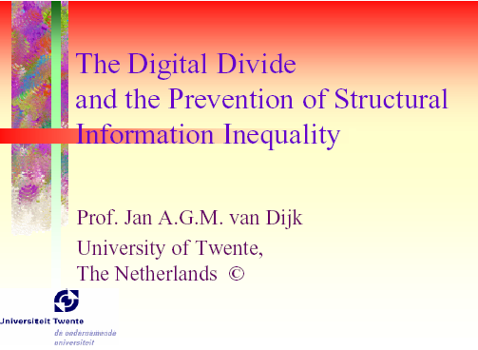
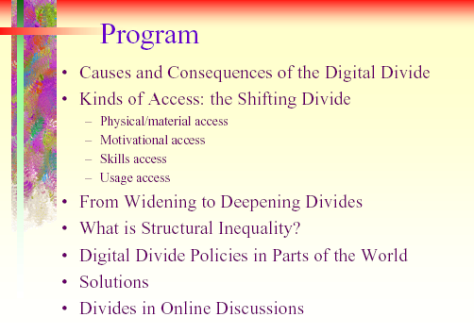
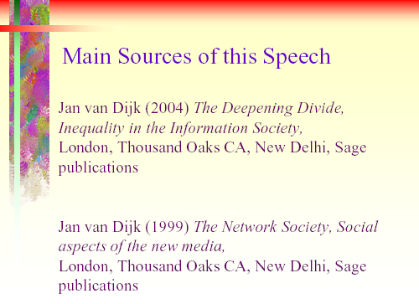
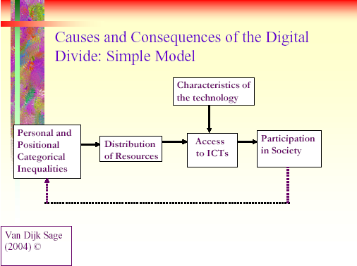
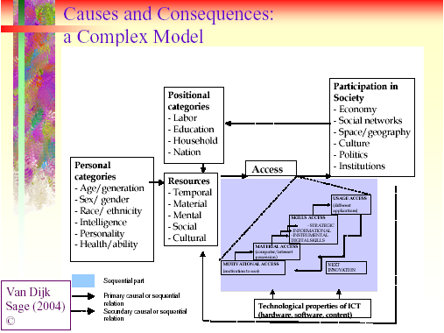

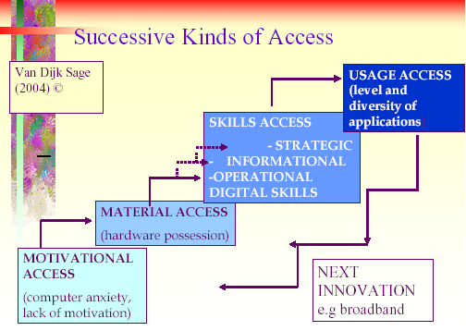
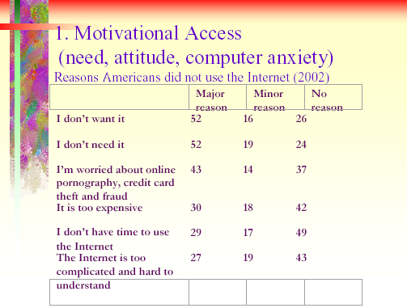
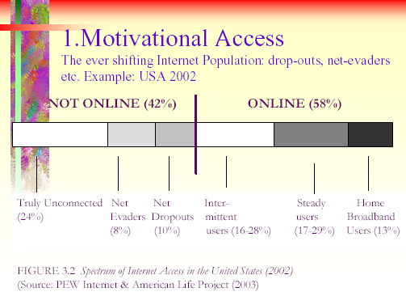
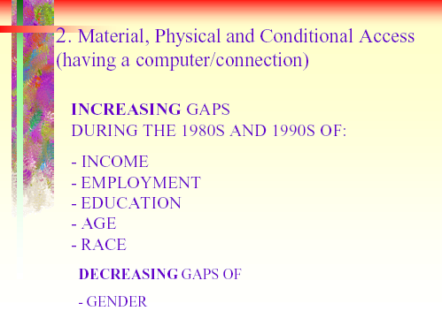
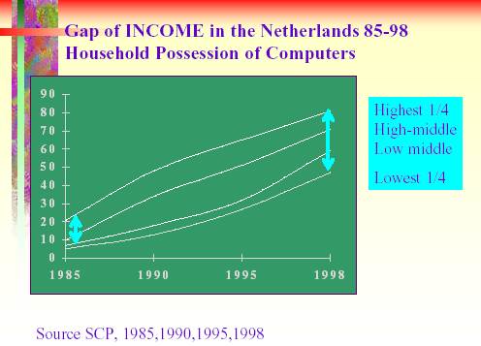

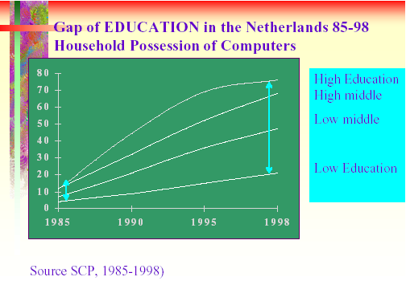
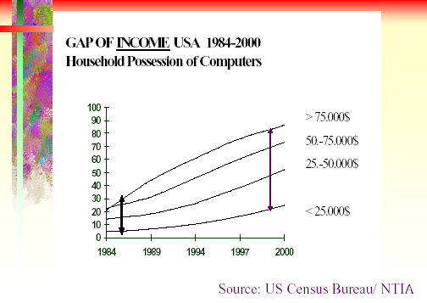
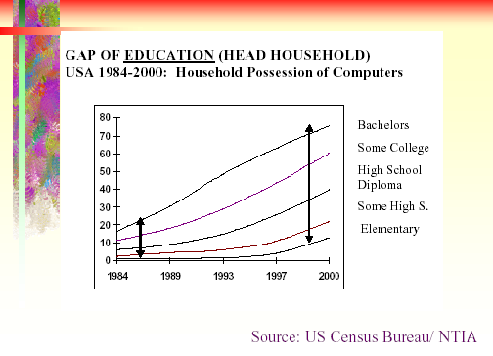
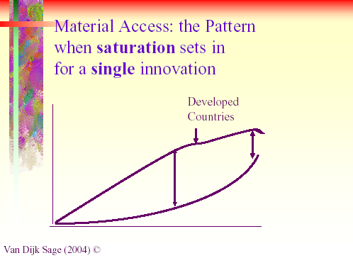
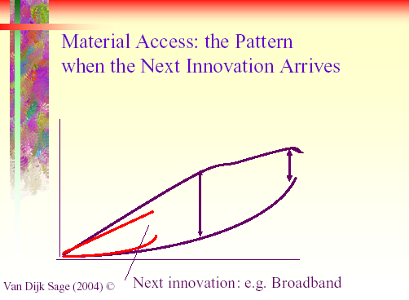
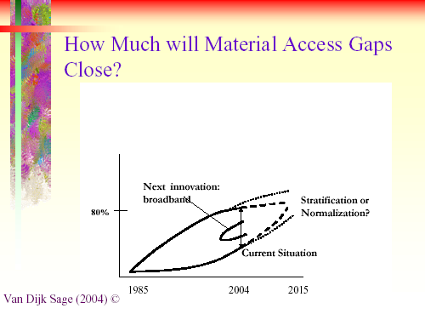

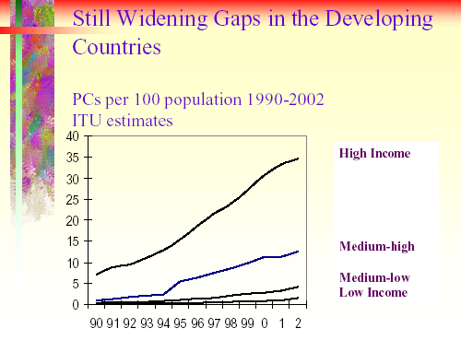
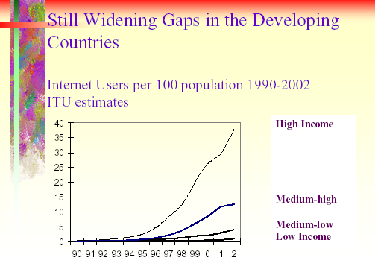
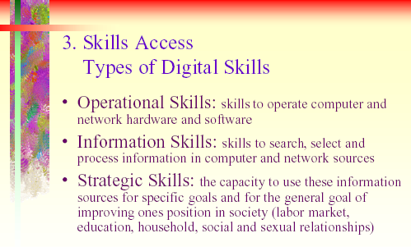
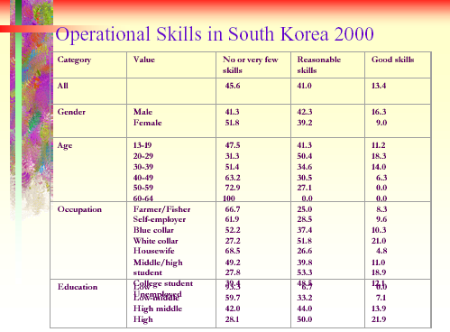

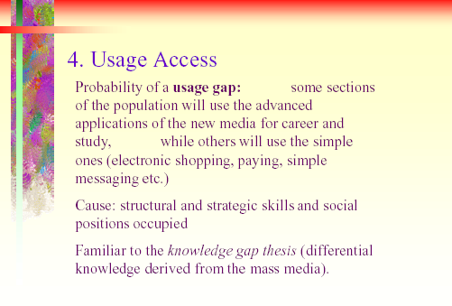
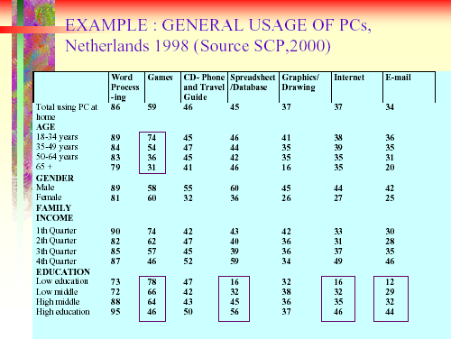
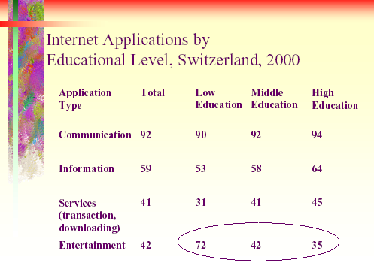
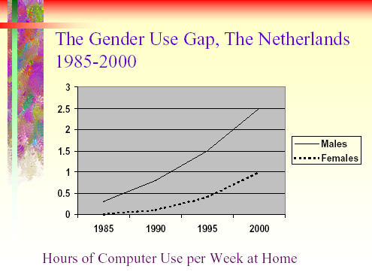

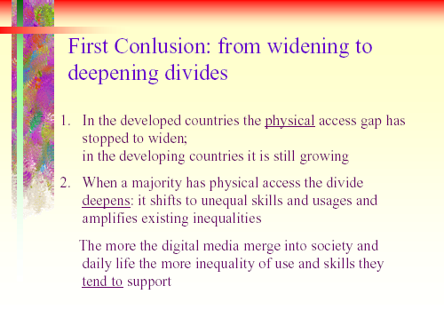
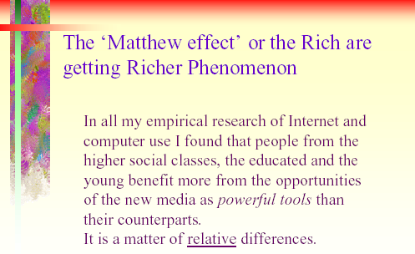
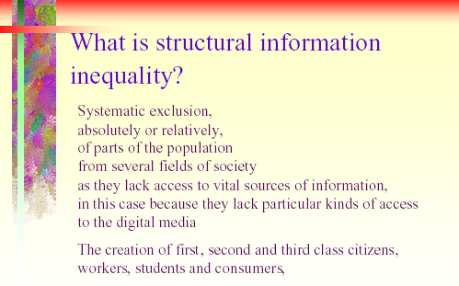
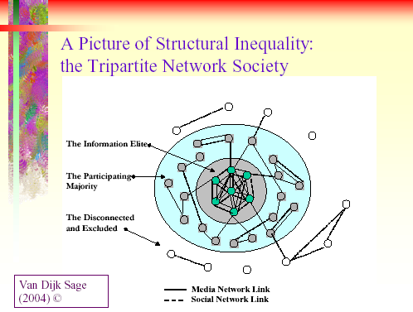

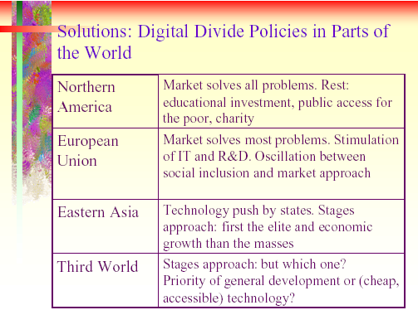
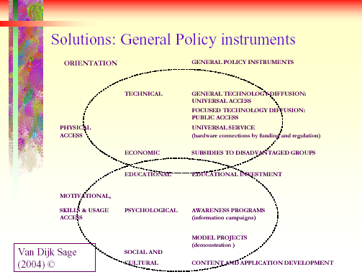

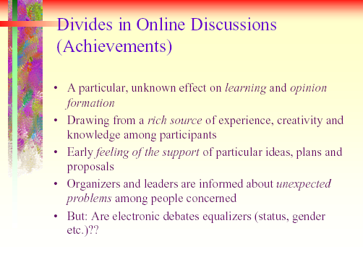
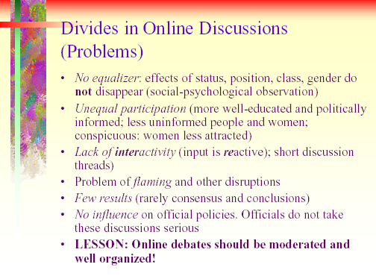

Digital Divide As A Complex And Dynamic Phenomenon

Professor Jan van Dijk, University of Twente
Department of Communication

Abbreviated and adapted from
an article with the same name in The Information Society,
Vol. 19, Nr.3, 2003 pp. 315-326
The multifaceted concept of access

Presently, hot discussions are going on in America and Europe, in particular, about the question whether there is a so-called ‘digital divide’ or not. And when it is deemed to exist, the next question becomes whether it will close or widen in years to come. Most of this discussion is politically charged. Old views reappear about markets and people solving all problems by themselves, or not, and about the need or rejection of government intervention.
The first obstacle in all research and discussion on information inequality is the multifaceted concept of access. It is used freely in everyday discussions without notification that there are many divergent meanings in play. The meaning of having a computer and a network connection is the most common one in the context of digital technology. However, according to Van Dijk (1999) this only refers to the second of four successive kinds of access. Van Dijk distinguishes four kinds of access:
- Motivational access: a lack of interest, computer anxiety and unattractiveness of the new technology
- Material access consisting of physical access (possession of a computer and an Internet connection, publicly or privately) and conditional access (username and password acquired by payment of membership)
- Skills access: three types of digital skills: 1. operational (being able to operate hard and software) 2. informational (being able to search, process and select information) and strategic (being able to use the technology as a means for ones own goals in work, education and social life.
- Usage access; differences in the number and kind (diversity) of computer and Internet applications used.

Clearly, public opinion and public policy are strongly pre-occupied with the second kind of access. Many people think the problem of information inequality regarding digital technology is solved as soon as everyone has a computer and a connection to the Internet. The first kind of access problem, the mental barrier, is neglected or viewed as a temporary phenomenon only touching old people, some categories of housewives, illiterates, and unemployed. The problem of inadequate digital skills is reduced to the skills of operation, managing hardware and software. Sometimes this is also viewed as a temporary phenomenon to be solved shortly after the purchase of a computer and a network connection. Differential usage of computers and network connections is a neglected phenomenon as well. Usually it is not seen as being of any importance to social and educational policies as differential usage is presumed to be the free choice of citizens and consumers in a differentiating post-modern society. So, there is a strong material or ‘hardware orientation’ approaching access to digital technology. We can see this in the most prevalent manners of framing the ‘digital divide’ to this date.
According to Van Dijk (1999) access problems of digital technology gradually shift from the first two kinds of access to the last two kinds. When the problems of mental and material access have been solved, wholly or partly, the problems of structurally different skills and uses come to the fore. Van Dijk defines digital skills not only as the skill to operate computers and network connections, but also as the skill to search, select, process and apply information from a superabundance of sources. He expects the appearance of a usage gap between parts of the population systematically using and benefiting from advanced digital technology and the more difficult applications for work and education, and other parts only using basic digital technologies for simple applications with a relatively large part of entertainment. Van Dijk stresses that computers are more multifunctional than any medium before.

Some facts: a digital divide in the USA, Europe and the rest of the world.

- Motivational access
Mental access problems come forwards when it is claimed that there are not only information have-nots’, but also information want-nots’. So there also are important motivational problems. In general, it appears to be possible to live and work without digital technology at the turn of the century. In 1999 a couple of European survey’s were published revealing that about half of the population not connected to the Internet also did not want such a connection. One of these survey’s was the German Online Non-users Survey (ARD/ZDF, 1999). Among the 501 non-users in this representative sample for Germany 234 (54 per cent) declared they certainly would not connect to the Internet for a mixture of reasons like: I don’t need it, I don’t like it, I can’t buy it and I can’t handle it. The same reasons were given by households in the US having a computer or WebTV in the year 2000, but never accessing the Internet (NTIA, 2000): ‘don’t want’ (31%), ‘too expensive’ (17%), ‘can use it elsewhere’ (10%) and ‘no time’ (9%). Presumably, there is some ‘gap of motivation’ among the populations of (even) high-tech countries. People with old age, low education, a large proportion of women and (functional) illiterates are strongly over-represented at the one side of it (ARD/ZDF, 1999a, NTIA, 2000) . Further research for the ingredients of the mixture of reasons observed here (anxiety, negative attitude, lack of motivation) is urgently needed.

2. Material access
Current discussions about ‘digital divides’ are completely dominated by the (lack of) availability of the hardware to everyone. Here we have an abundance of data. Increasingly, longitudinal data in official statistics are supplied. They do reveal strong evidence of digital divides in the possession of computer and network connections among a number of social categories during the 1980s and 1990s: income, education, occupation, age, gender, ethnicity and geographic location. By constructing time series from these data, it can be shown that most of these gaps of possession have increased during the 1980s and 1990s (see Van Dijk & Hacker, 2003). The good news is that the original gender gap in actually using PCs and the Internet decreased during the 1990s. In the year 2000 the gender difference in the possession of computers and the Internet and the time of using them has been equalized in the US (see NTIA, 2000) – in the EU women are still catching up (see the annual Eurobarometer survey’s of the EU) – but skills and kind of usage remain different (see Tables 1,2 3 and PEW, 2000).
The big question connected to the observation of the widening gaps is whether these trends will go on like this. From statistical (population) reasoning it is evident that it will not. Saturation of computer and network possession among the ‘higher’ categories will set in, and presumably has started already in countries like the US and the Netherlands. For the ‘lower’ categories there is much more space to catch up. So the actual question becomes how much gaps will close in the first two decades of the 21th century, and what is more important, what kind of computers and network connections people will possess.
However, at the global level the digital divide of material or physical access is far from closing; on the contrary it is still widening as the following figures of computer and Internet access in the world reveal:

High Income

Medium-high

Medium-low
Low Income

Figure 4.4a Personal Computers per 100 Population in High, Medium and Low Income Countries 1990-2002 (ITU estimates) Source: United Nations Statistics Division (2003)

Low Income
Medium-low
Medium-high
High Income
Figure 4.4b Internet Users per 100 Population by High, Medium and Low Income Countries 1990-2002 (ITU estimates) Source: United Nations Statistics Division (2003)

3. Skills access
PCs and computer networks were renowned for their user-unfriendliness until well into the 1990s. Major improvements were made with the introduction of graphical and audio-visual interfaces. However, the situation is still far from satisfactory. Gaps of digital skills have been revealed in several studies. The most common definition of digital skills is operational skills: the ability to operate hardware and software. In the study concerned digital skills were made operational using an index called ‘informacy’ measuring both skills of operating digital equipment and skills of searching information using digital hardware and software. This means that so-called informational skills are added to the definition. Below we will suggest to add a third type of digital skills in succession to the operational and informational ones: the strategic skills of using information for ones own purpose and position. Figure 3 with multiple regression analyses reveals the (perhaps) surprising result that digital skills (instrumental and informational, together called ‘informacy’ here) are not primarily related to educational levels but to age and gender. Probably, this means that real practice and motivation are more important in acquiring digital skills than formal education. Indeed, many studies reveal that having computer experience at work, having particular hobbies and having a family with schoolchildren are decisive factors in the acquisition of digital skills by adult people.

4. Usage access
In this paper and on other occasions (Van Dijk, 1997,1999,2000) it is predicted that different uses of ICT will bring the most important digital and information inequalities in society. The latest Falling Through the Net study (NTIA, 2000) reveals important differences of Internet usage by income, education, ethnicity and other variables, but unfortunately only informational, educational and work-related types of Internet use were reported. It appears that with rising educational levels the Internet applications of information searching, doing job-related tasks, searching for jobs and using e-mail increase significantly (see NTIA, 2000, Figure A49). Opposed to that people with lower education use the Internet relatively more to take courses. Taking courses and searching for jobs on the Internet is practiced more by Americans with low incomes than with high incomes in the year 2000. The same goes for unemployed Americans as compared to the employed (see NTIA, 2000, Figures A47 and A50). This reveals the importance of usage access and skills access compared to their necessary condition, material access. Having a computer and Internet connection and having the skills to use them are becoming increasingly important resources on the labour market.

Conclusions and Policy Perspectives

Following the line of the argument in this paper the complexity of the picture of the so-called digital divide comes to our mind. A number of significant divides have been observed and supported by relatively reliable official statistics and survey’s. However, there is no question of an absolute, yawning and unbridgeable gap between two classes of people. Talk about ‘technological segregation’ (NAACP President Kweisi Mfume) and ‘classical apartheid’ (Reverend Jesse Jackson) is exaggerated and misses the point. The point is that the gaps observed show first of all relative and gradual differences. This makes them no less important. In the information and network society relative differences in getting information and lines of communication become decisive for ones position in society, more than in every society in history before. Giving everybody a computer and a network connection, banning the cutting lines of ‘segregation’ in this way, will not remove them. Much deeper and clear-cut differences in skill and usage will come forward because both technology and society are differentiating stronger than ever before. The fundamental task of future society will be to prevent structural inequalities in the skill and usage of ICTs becoming more intense. Inequalities become structural when they ‘solidify’, that is when positions people occupy in society, in social networks and in media networks, or other media, become lasting and determine to a large degree whether they have any influence on decisions made in several fields of society.
Another reason for the complexity of the digital divide is that there are in fact several divides. Some are widening while others are closing. Time series of official statistics have demonstrated that during the 1980s and 1990s gaps of income, employment, education, age and ethnicity in the possession of computers and hardware have grown, at least in the USA and the Netherlands. Clearly, the people at the ‘better side’ of these gaps have increased their lead during these decades. Though these gaps of possession will (at least partially) close in the next decades, if only for the statistical reason of saturation effects, it is very unlikely that those having acquired a big advantage will stop and lean backwards. Technology is advancing, splitting in simple and highly evolved applications, spreading into society and sticking to old and new social differences.
In the course of the 1990s the gender gap in the possession of ICTs has started to close. However, gender gaps in skill and usage remain or mature, though they are much smaller for girls and boys than for adults (see GVU, 1994-1999, ARD/ZDF, 1999b, SCP, 2000 and PEW, 2000).
Large differences of digital skill and usage were observed recently. Here gaps might grow in the future, though this can’t be proved at this moment for a lack of time series data.
The conclusions above have also highlighted the dynamic nature of every digital divide. One should not stop at a particular point in time and say: look, this particular technology or application will be available to everybody within a couple of years. Information and communication technology will differentiate considerably in the first decades of the 21th century. Computers will be available in the simplest (palmtop and other) forms and very advanced types of desktops, laptops and servers. ‘The Internet’ will be accessible via televisions, mobile phones and other small information appliances next to fast broadband connections. An important policy question will be whether palmtop computer and mobile phone or all kinds of narrowband access will be sufficient to be called the basic connection every citizen needs. Moreover, what does basic access to the Internet mean: both at home and at work/school or is one of them sufficient, or perhaps even a connection in a public utility?
An important characteristic of ICT in this respect is its extended multifunctionality. Printed media, radio, television and telephone have all been used differently by people with high and low education in particular. However, their (difference in) functionality is small compared to computers and the Internet. In the mean time society is also differentiating at an unprecedented scale. Together they may create a usage gap that is somewhat familiar to the knowledge gap described by Tichenor et al. a long time ago. “As the diffusion of mass media information into a social system increases, segments of the population with a higher socio-economic status tend to acquire this information at a faster rate than the lower status segments” (Tichenor et al., 1970, p. 159).
Though the evidence in favour of the thesis of knowledge gap has not been conclusive (Gaziano, 1987) it might get another chance in the information or network society where information is a positional good. We propose to relate this gap to a usage gap, not primarily based on differential derived knowledge or information but on differential practical use and positions in society.
The policy perspectives to be linked to this analysis clearly depend on ones central objectives concerning information inequality and ones political position. Central objectives might be twofold. The most basic one is social inclusion. A step further is made in the objective of an equal distribution of resources or life chances. The first objective is backed by a big coalition of forces in advanced high tech societies. Corporations look for a large electronic market place. Politicians want extended reach for political persuasion and a grip on new channels of political communication bypassing traditional mass media. Military people and security agencies want everybody to be connected for purposes of control and surveillance, as the off-liners of the future will create unknown risks. Educators are concerned about universal and public access to all learning resources. Community builders want every citizen to be involved in online communications linked to offline local activities.
The second objective is more traditional and it is supported more in Europe than in the US, for instance. The minimum is an equal distribution of chances to every individual, an objective also having a broad support. Filling in what this means for actual material, social and cognitive resources reveals the differences of political position.
The author of this paper wants to link policy perspectives to the four kinds of access distinguished. According to them governments, civil societies and markets all have a job in the support of these kinds of access.
Elementary digital experience is first of all a question of the market developing and offering ICTs that really are user-friendly and that offer such a clear surplus value as compared to old applications that the ‘information want-nots’ will be convinced. Even on that occasion many elderly and low educated people and some categories of housewives will stay behind. This will be the most important mission of adult education to be offered by governments, community centres and corporate training.
Concerning the general possession of computers and networks markets have done a good job lowering prices for technologies with higher capacities. However, this has not prevented the growth of digital divides in the possession of hardware, at least until very recently. Household income is still the most important factor here. So, tax and income policies of governments certainly do make sense. However, general tax credits or subsidies are not effective. They have to be focussed on the groups clearly staying behind, all of them in the lowest quarter of the income distribution. A second qualification is the need of public or private service and guidance. Just offering cheap boxes with computers and Internet connections makes no sense.
Learning digital skills will be a strategic objective for educational institutions at all levels. The official American and Dutch survey’s cited in this paper indicate that present digital skills are learned more at work than at schools or at home. In general, formal education runs behind because means are lacking and teachers are not sufficiently trained or motivated. Filling in this strategic objective it will become evident that digital skills do not only mean abilities to operate the hardware and software (instrumental skills). Increasingly, it will mean the ability to search, select, process and apply information (informational skills) from digital sources and to strategically use them to improve ones position in society (strategic skills). At least instrumental and informational skills have to be learned at schools.
Improving usage opportunities for all means making them more attractive to some people in the first place. We have observed the surprisingly high independent effects of age, gender and ethnicity (in the US) for the actual use of ICTs. Applications should be made more attractive to many old people, women and ethnic minorities. This is a matter of design, culture, language and identity included and addressed in the applications concerned. Producers, designers and representatives of citizens and consumers have a job here.

References
ARD/ZDF-Arbeitsgruppe Multimedia. 1999a. ARD/ZDF- Online-Studie 1999. In: Media Perspektiven 8/99, 388-409.

ARD/ZDF-Arbeitsgruppe Multimedia, 1999b. Internet – (K)eine Männerdomäne. In: Media Perspektiven 8/99, 423-429.

Gaziano, C. 1983. The knowledge gap: An analytical review of media effects. Communication Research, 10, 447-486.

GVU -Centre , Georgia University. 1994 -1999. GVU’s 1th -10th WWW User Survey’s. http://www.gvu.gatech.edu/user_survey’s/.

Kominski, R. and E. Newburger. 1999. Access Denied: Changes in Computer Ownership and Use: 1984-1997. Paper presented at the Annual Meeting of the American Sociological Association, August 1999, Chicago Illinois.

NTIA (US Department of Commerce department). 2000. Falling through the Net IV: Towards Digital Inclusion.
Abailable: http://www.ntia.doc.gov/ntiahome/fttn00/contents00.html.

Pew Internet & American Life Project. 2000. Tracking online Life: How women use the Internet to cultivate relationships with family and friends. PEW: Washington DC. Avalable: www.pewinternet.org .

SCP (Sociaal-Cultureel Planbureau/ Social-Cultural Planning Agency), Van Dijk, Liset, J. de Haan and S. Rijken, Authors. 2000. Digitalisering van de Leefwereld, een onderzoek naar informatie en communicatietechnologie en sociale ongelijkheid. Contains a Summary in English, Rijswijk, The Netherlands: SCP.

Tichenor, P.J., G. Donohue & C. Olien. 1970. Mass media flow and differential growth in knowledge, Public Opinion Quarterly, 34. 159-170.

US Census Bureau. 1984, 1989, 1994,1997, 1998, 2000. Current Population Survey’s.

USIC (United States Internet Council ). 1999. State of the Internet: USIC’s Report on Use & Threats in 1999. Available: htpp://www.usic.org/usic_state_of_net99.htm.

Van Dijk, Jan A.G.M. 1997. Universal Service from the Perspective of Consumers and Citizens, Report to the Information Society Forum, Brussel: European Commission/ISPO.

Van Dijk, Jan. 1999. The Network Society, Social aspects of new media. London, Thousand Oaks, New Delhi: Sage.

Van Dijk, Jan. 2000. Widening Information Gaps and Policies of prevention. In: Hacker, K. & Van Dijk, J. (eds). Digital Democracy, Issues of theory and practice. 166-183. London, Thousand Oaks, New Delhi: Sage.

Van Dijk, Jan & K. Hacker. 2003. The Digital Divide as a Complex and Dynamic Phenomenon. The Information Society, Vol. 19, Nr. 4, pp. 315-326.

REPORTS FROM THE WORKING GROUPS

Working Group on International Civil Society Organisations

Report: Michael Schwarz

- Problem Posed: How to get relevant information from the Internet?
Suggested Solutions:
  - Short messages from the administrator to member organisations, with links to new documents that might be relevant
  - Send solely the relevant address and hence avoid sending large documents by e-mail

- Offer an Information package on how to use the Internet as a medium for various forms of campaigns

- Set up a roster of organisations within the various networks, which report problems in the forum to solicit solutions from other members of the forum. Important for the members is that they are informed as to what specific dates new problems or issues will be posted on the forum Web-site.

- e-mail alert:
- if there are new entries in the forum
- only if option to receive or not receive such emails is offered (to avoid too many unsolicited emails)
- incorporate a further function offering the possibility to send an email to all members of the forum simultaneously and not only through the moderator or administrator.

- Hold a workshop on Internet-functions within the networks, perhaps in a computer lab

- Hold such a workshop virtually on the internet as an online-workshop

- Include a notice board in all networks – as opposed to email communication, so that new information can be obtained whenever a member thinks fit, and not when the sender thinks fit

- Introduce a calendar of events, where members can advertise upcoming events

- Introduce a calendar of current topics so that members may advertise which topics they are currently dealing with

- Reflect on the possibility to issue more passwords per organisation, so that
- more than one member can take part in online discussions
- there is the possibility to use the forum within a member organisation
- there is the offer of a hierarchy of passwords:
a.) to take part in discussion boards and
b.) to change or enter information about member organisations

Working-Group: Network of Central and Eastern European Countries (CEEC)

Report: Thomas Kloiber

Lines of discussion:
- The access of the Central and Eastern European Countries to digital technology is rather varied. There is no common level. It depends on the structure and the kind of organisation involved. Participants mentioned on the one hand that they have positive experience in networking with partner organisations in CEEC even though, as a participant from Croatia told the group, even without having a PC in his organisation.

- The Study on the Contributions of Civil Society Organisations to the Well-Being of Families since IYF 1994 shows that NGO´s from CEEC try to make contact with partner organisations in western Europe and to join a network. It can be said that there is a basic need for networking in CEEC.

- An interactive platform on the internet would facilitate the process and progress of working groups. Members of international NGO´s would have the advantage to consider a text, a project, or whatever else, on a forum for members. This process has the same effect for forums or committees. It helps to save financial and time resources.

- A common platform for NGO´s would also help organisations which, do not have
adequate technical access. It would be easier to profile the organisation on a platform, than to administer its own homepage. It also helps to avoid the current competition of making the best and most attractive homepage.

- An important question for the group was how to combat the digital divide. It is certain that NGO´s have to help to bring the internet to those poorer off. One solution would be technical: Access must become cheaper and easier.

Results and Recommendations:

- The Committee should support the creation of NGO office communities by helping them to buy hardware for internet access. This single organisation would have to share the costs of the administration. The advantage would be to facilitate communication between the NGO´s themselves and also with the Committee.
- A follow-up to the Interactive-Internet-Forum IYF, which would have a similar structure, should be set up, but open world-wide with special areas for each continent. The name of this platform could be “IYF+”, which would indicate continuity and progression. The platform should offer an opportunity for NGO´s to profile themselves, to make their own newsletter and to offer a registration form to request it. Fundraising could be made on this platform, in a combined way, to become more effective.

Summary and Outlook beyond the 10th Anniversary of IYF

Peter Crowley

The Chairperson began the summing up by expressing the appreciation of the Committee to the Austrian Federal Ministry for Social Security, Generations and Consumer Protection, for its co-operation and support in facilitating the organisation of the seminar. Appreciation was also extended to the protocol and conference staffs of the United Nations in Vienna, to the distinguished presenters and to the participants, who made such valuable contributions to the working groups, which were an integral part of the seminar, and in the discussions from the floor and last and not least, to the members of the Vienna NGO Committee on the Family for their generosity of time in organising the seminar. He mentioned the positive feed-back from the participants, with regard to the high quality of the presentations and the various discussions, as well as for the opportunity to network, especially at the civic reception at the invitation of the City of Vienna.

The contents of the presentations addressed the scope, opportunities, limitations and difficulties involved in various forms of networking, which of course is not offered as a

panacea to deal with all the challenges facing civil society organisations.

The Chairperson remarked that the composition of the podium at the opening of the international seminar the previous day, reflected the concept of partnership between the actors in the social and political field, through the presence of the representatives of the United Nations, the Austrian Government, and Civil Society, incorporating Academia and NGOs. He reminded the participants that in recent literature and in the media, the term ‘Civil Society’ has become more prevalent than NGOs, encompassing a wider concept and drew their attention to the constitution of the High Panel on Civil Society convened by the United Nations Secretary General in 2003.

He recalled that the first day of the seminar set out the background for the seminar with the presentation of Prof. Frost on Global Civil Society, along with the statement from the United Nations and the opening statement by the Chairperson, both of which stressed the centrality of family to society and the emphasis on regarding families in the light

of what they do, rather than what they are, as well as the statement of the Austrian Government on the implementation of family policy. The emphasis on what families do, rather than what they are, or should be, is also an attempt to de-politicise the debate on families.

Despite the obvious shortcomings of any two day seminar, this was an opportunity for civil society, government and international organisations to further sharpen their awareness on family issues and to benefit from a cross-pollination of participants from a broad spectrum of society.

A comprehensive report on the proceedings of Seminar will be published shortly, thanks to the distinguished presenters supplying electronic copies of their presentations, for which the organisers are very grateful.

The Chairperson reminded the participants that the three Interactive-Internet-Forums the Committee has facilitated setting up, with the cooperation of the participating civil society organisations, are vehicles to interaction on matters of content or substantive issues, and not just an end in themselves.

Global Civil Society with its ‘language of civil rights’, which is the basis of all interaction, is unconquerable without being omnipotent. The power of civil society derives from pooling its resources, resulting from the actions of individual rights holders, as Prof. Frost reminded the participants. So one person can make a difference in this domain of freedom that is without borders.

Civil Society Organisations, as the Chairperson pointed out, are constantly challenged to assess and reassess, their own democratic structures of transparency and accountability, as well as their contributions to the well-being of families and the role they play in enhancing social justice, in society in general, both at the local, national and international level.

The Chairperson recalled the presentation of Prof. Van Dijk, who stressed the importance of ‘motivational access’ and not just physical access, to the Internet. This concept can become vitally important with regard to the endeavours of civil society organisations toward social inclusion, especially when Internet forums lead to truly interactive dialogue, by making use of the linkages provided and not just settling into a reactive mode of communication. However to avail of the technology already at hand to interact, it may be necessary to overcome anxieties and a lack of motivation, which some still have with regard to interactive technology. Making use of interactive technology, as the Chairperson noted in his opening statement, could help to transfer information into ‘ecologies’ of knowledge and build out of virtual networks of practice, sustainable communities of shared disposition (Brown & Duguid 2002).

The ‘strategic skills’ developed with the support of the Internet Company, which laid out the benefits of Interactive Forums on the Internet for the well-being of families, have been of great benefit to the Vienna NGO Committee on the Family in its efforts to be truly institution building. The Chairperson expressed his appreciation of the contribution and commitment of representatives of the younger generation present to the endeavours of the Committee in setting up institution building networks.

This international seminar was organised to celebrate the International Day of Families and in observance of the 10th Anniversary of the International Year of the Family in 2004 (IYF).

The Objectives of IYF

A careful reading of the objectives set out for IYF in 1994 show how relevant the aims, motto and theme of IYF still are during the 10th anniversary of IYF in 2004. The theme of IYF was "Family: resources and responsibilities in a changing world" and its motto: "Building the Smallest Democracy at the Heart of Society".
The objectives of IYF as set out in 1994, were to stimulate local, national and international action as part of a sustained long-term effort to:
Increase awareness of family issues among Governments as well as in the private sector. IYF would serve to highlight the importance of families; increase a better understanding of their functions and problems; promote knowledge of the economic, social and demographic processes affecting families and their members;
Enhance the effectiveness of local, regional and national efforts to carry out specific programmes concerning families by generating new activities and strengthening existing ones;
Improve the collaboration among national and international non-governmental organisations in support of multi-sectoral activities;
Build upon the results of international activities concerning women, children, youth.
(cf.)
www.un.org/esa/socdev/family/index.html
www.10yearsIYF.org
As indicated in his opening remarks yesterday, the Chairperson maintained that there has been a shift from awareness raising, to institution building, while of course institutions carry on the function of awareness raising as well. He then went on to focus on measures that political actors in the social field have taken with regard to the 10th Anniversary of IYF.

National Priorities of United Nations Member States

In summarising the Report of the Secretary-General of the United Nations to the Commission for Social Development (CSD) 4-13 February 2004, on the Preparation for and Observance of the tenth anniversary of the International Year of the Family 2004 in UN document E/CN.5/2004/3 which was prepared with the assistance of information provided by many governments, in reply to a ‘note verbale’ of the United Nations Secretariat, it can be observed that national plans and programmes for the 10th anniversary of IYF usually entailed a research, legislative and policy component, support for facilitative services, specific measures for special subgroups of families, a private-sector component and awareness-raising components. Over 90 of the Member States of the United Nations had both formulated a national programme of action for the 10th anniversary as well as establishing a national coordinating committee for 2004, many of which were created by the head of State.

Long standing national priorities for family policies, such as gender equality, reconciliation of work and family life, domestic violence, migration, children’s rights in the family, the role of fathers, marriage and divorce issues, changing family forms, intergenerational relations, drug abuse and HIV/Aids prevention and care, to mention but a few, from the summary, have been given new impetus since 94.
The Report of the Secretary-General concludes in making four recommendations to:
“(a) Strengthen cooperation and mechanisms for consultation and advocacy at the national and local levels in order to promote greater consensus on policy content, concepts and an integrated perspective on the family;
(b) Enhance international cooperation in the area of family research to assist in policy formulation and evaluation;
- Promote training and advisory services for the analysis, formulation and evaluation of integrated strategies, policies and programmes;
- Continue to support the United Nations Trust Fund on Family Activities to assist in national capacity-building and development cooperation.”

Networking by CSOs attends to three of these recommendations, consultation and advocacy, international cooperation, promoting training and advisory services. The fourth is a matter mainly for governments to support, namely continuing to resource the Trust Fund.

IYF and its 10th Anniversary gave inspiration and motivation to many local, national and international NGOs to focus on a family orientation in their endeavours, and many of them have sought a constructive dialogue with governments by openly accepting the role of partner, which is increasingly offered to NGOs.

The Centrality of Families in Society and Social Development
As the United Nations Secretary-General stated in his message on the launch of the observance of the tenth anniversary of the International Year of the Family on December 4th 2003 “families have always been the essential social unit in all societies.” This reiterates the Twenty-fourth Special Session of the General Assembly, Geneva 26 June-1 July 2000) “that the family is the basic unit of society and that it plays a key role in social development and is a strong force of social cohesion and integration.” It would hence seem appropriate to take a family-focused approach to national and international co-operation for social development thus benefiting from partners directly involved in the intricate day-to-day challenges confronting society.
Issues such as:
- The paradigmatic changes in demographic development, also in developing countries is having long term consequences for society. The United Nations projects that before 2050, 80% of the world population will have below-replacement levels. The concern is not the drop in fertility rates, as such, especially as many of those children would be born into poverty. Of concern is the grade and speed of this development and the capacity of society to deal with its consequences. This fact in synergy with an ageing society leads to,
- the seriously threatened break down in the intergenerational contract, where one generation guaranteed the economic survival in old age of the other.
- The HIV/Aids pandemic, which partly wipes out in many countries and regions, the parent or “carer generation”, leaving grandparents to look after their grandchildren, without any rights in this relationship, until they themselves become infirm and need to be cared for by the grandchildren, who are often too young and ill prepared to do so.
- Ca. 50% of the world population is living in poverty on less than US$2 per day, mainly within a family structure.
- Increasing migration through conflict, or economic necessities for survival, usually takes place within families.
- The hunger of humans for knowledge, especially in childhood, youth and early man-and womanhood needs co-ordinated education policies,

are all issues, which go right to the core of the sustainable development of society, and hence would seem to necessitate policies which have a family orientation, in order to address issues of sustainable development comprehensively and holistically.

The challenging changes in society are usually interwoven with paradigmatic changes in families. For many years family issues have been regarded as problematical areas, which needed support, like another charity. Would it not be more meaningful instead, to recognise families as the human capital, wealth and resource of society, which they, without dispute, are, and hence regard families as the medium and motor, to attain true social and sustainable development?

The Chairperson remarked that civil society organisations could, unwittingly, be further perpetuating the view of families issues as another charity, by overly stressing the concept of ‘supporting families’, and admonishing the lack of support from some governments, rather than emphasising the concept of how families themselves support and replenish society itself, while at the same time recognising that there are families which also need the support mentioned.

We trust that the tenth anniversary of the International Year of the Family in 2004 will re-emphasise the permanence of family issues as central to the work and programmes of the Commission for Social Development of the United Nations. We further trust and welcome the fact that the General Assembly of the United Nations will give priority to continue funding for family issues within the Secretariat of the United Nations, which is essential to maintaining collaboration and partnership between governments, International and Civil Society Organisations, for the well-being of families, which again is central to the process of social and sustainable development.

Report on The United Nations Consultative Meeting on Mainstreaming the Family Issue
New York December 2003

The Chairperson reiterated his appreciation to Mr. Huber, for his clear statement made at the opening, on the continued commitment of the United Nations to the programme on the family and went on to recall the publication of the report on The United Nations Consultative Meeting on Mainstreaming the Family Issue, which was held in New York from 10 to 12 December 2003 and organised by the Division for Social Policy and Development, Department of Economic and Social Affairs (DESA). Having participated in the meeting in New York, the Chairperson maintained that this report is encouraging for all concerned with issues regarding families, which notes that the participants from six countries „made a distinction between efforts to “strengthen the family”, which is a vague concept, and efforts to strengthen and support the functions that families perform. They voiced concern for formulating family policies within the framework of socio-economic development. […] It was further clearly stated, that the family, as the basic unit of society, is by virtue of that definition not marginalized but central to, and already in the mainstream of, society. […]

The irony is that, often, the centrality of family has escaped the attention of policymakers. There has therefore been insufficient attention paid to the impact of policies on families, and insufficient regard for the contributions families make to the well being of their members.”

The report of the Consultative Meeting continues by stating that “Civil society is a strategic partner to both the United Nation and Governments. Indeed, civil society organizations are a resource of the self-organization of society and their networks. In the area of families, civil society serves as a collaborative partner in a variety of salient activities such as training and education. This partnership is further endorsed by the High Level Panel on Civil Society, created in 2003.”

The participants of the Consultative Meeting made the following recommendations:

- “To integrate family issues in national development policies and programmes, the establishment of three institutional pillars was considered highly desirable. First, a national commitment at the highest level of government, preferably in the form of a declaration, or proclamation, by the Head of State. Second, an effective national coordination mechanism. Third, appropriate family support legislation that takes into account the country’s cultural, environmental, social and economic conditions.”

- “A healthy partnership needs to be maintained between Governments and concerned organizations of civil society (including NGOs, academia, professional societies and institutions, trade unions, employers federations, chambers of commerce and industry, the legal and medical professions, and other stake holders), especially through their participation in the national coordination mechanism.”

- “The United Nations has a catalytic and supportive role in strengthening and enhancing concern for the family at the national, regional and global levels. This role can best be exercised by assisting in integrating family perspectives in the development process. In the exercise of this role, the Division for Social Policy and Development should maintain a focal point for the family, incorporating in-house expertise to carry out an effective programme of work. This programme of work would be promotional and aimed at strengthening national capacities through the implementation of the objectives of the International Year of the Family entailing, inter alia, the provision of technical assistance to national coordination mechanisms, diagnostic studies, exchanges of expertise and experiences on salient family issues, orientation and training, research and data collection, information dissemination, networking at sub-regional, regional and inter-regional levels, and policy and programme coordination within the United Nations system, and with other inter-governmental and non-governmental organizations. The programme should highlight advocacy, capacity building and technical support to Governments, at their request, on the family issue.”

The full text of the Consultative Meeting is on the United Nations Website at: www.un.org/esa/socdev/family/Meetings/meetingsframe.htm

The Chairperson informed the participants of a briefing in the United Nations on May 13th 2004 in New York entitled: “The Family Today: Emerging Issues on the International Agenda (In Observance of the 10th Anniversary of the International Year of the Family)” along with Jose Antonio Ocampo, Under-Secretary-General, Department of Economic and Social Affairs of the United Nations, Claude A. Allen, Deputy Secretary, United States Department of Health and Human Services, Ms Aster Zaoude, Senior Gender and Development Advisor, Bureau for Development Policy of the United Nations Development Policy, and that he had been invited to address the briefing as well, as Chairperson of the Vienna NGO Committee on the Family.

In conclusion, he drew the attention of the participants to further initiatives of the Committee for 2004, as listed in the Proposed Plans of Action,
(cf.www.viennafamilycommittee.org) and encouraged Civil Society Organisations to take up the offer of the United Nations to regard themselves as partners of Governments and International Organisations, and urged colleagues not to regard themselves solely as advocates, in the search for solutions to issues affecting families. It is, in the long term, up to civil society organisations themselves to accept the outstretched hand of friendship and partnership.

With expressions of deep appreciation to all the participants for their contributions to the many aspects of the past two days and wishing them well in their endeavours for the well-being of families world-wide, the Chairperson invited Mr. Bob Huber, Chief of the Generational Issues and Integration Section of the Division for Social Policy and Development of the United Nations in New York to officially close the seminar.

Concluding Remarks

Bob Huber

Mr Huber thanked the Chairperson for the very thorough review and analysis of the work that had been done during the two days of the seminar, which he personally found very interesting, and pointed out that the theoretical presentation of the input papers and the practical emphasis in the discussion by the participants, could be understood, as an example of the balance of the opportunities and challenges that lie before us.

He went on to point out that technology and the Internet clearly represent a bright future, while noting that each of us has a different ‘comfort level’ with this technology, which determines the process by which we avail of the technology. The young people of the Internet Company were exemplary, in their presentation, in helping us understand the potential of this technology.

He reaffirmed the commitment of the United Nations Division for Social Policy and Development of the Department of Economic and Social Affairs, to the Programme on the Family and thanked each of the participants for their contributions, every day, in their organisations and in the societies in which they live.

Mr Huber stressed that the United Nations takes the notion of partnership with civil society very seriously, while recalling, that ca. two decades ago, that there was quite a different, and more one-sided relationship, between the United Nations and NGOs. Then, NGOs were essentially invited to conferences, on a limited basis and mainly to spread the message of the United Nations. It is clear that this idea has changed tremendously into a two-way partnership with civil society, propelled particularly through the international conferences and summits of the last decade, making civil society a major contributing factor to the international debates, as well as helping to increase the understanding of governments and the United Nations System. This is a tremendous advance. With the availability of modern technology, under creative leadership, and counting on the young, this process can only go forward, and become truly interactive, in ways perhaps that we today, cannot even imagine.

In conclusion he reiterated his appreciation of the organisation and the invitation to the international seminar and of the rich discussion, which encourages participants to carry on their work, and stated that he would take the message back to New York. Mr Huber thanked all participants in the seminar for the work yet to come.

Projects of the Vienna NGO Committee on the Family are supported by:

- Arbeitsgemeinschaft der Bäuerinnen in Niederösterreich
- Austrian Federal Government
- Bank Austria
- Berndorf Gruppe
- Creditanstalt Bankverein
- E.F.T. Transportagentur GmbH
- European Commission
- Government of Germany
- Government of Liechtenstein
- Government of Luxembourg
- Government of Spain, Catalonia and the Balearic Islands
- INGOs
- Niederösterreichische Landesregierung
- Niederösterreichische Versicherungs AG
- OMV
- Shell Austria AG
- Schoeller-Bleckmann Oilfield Equipment AG
- Siemens
- Rotary International
- United Nations Trust Fund on Family Activities

'Families International' an information-sharing bulletin published by:
Vienna NGO Committee on the Family:
Brunngasse 12/2, A-3100 St. Pölten, Austria, Fax: 43-2742-35 27 18-5,
e-mail: famcom.vienna@utanet.at

Web: http://www.viennafamilycommittee.org
http://www.10yearsIYF.org
http://www.civilsocietynetworks.org

Printed by in-house duplication. The views published do not necessarily
reflect the views of the members of the Vienna NGO Committee on the Family.
Editorial Committee: Peter Crowley, Eva Matt, Michael Schwarz.
Co-Editors: Eva Matt, Michael Schwarz.
Layout: Sylvia Harling

. Michael Walzer, ed., Toward a Global Civil Society (Oxford: Berghan Books, 1995).
. Justin Rosenberg, The Empire of Civil Society (London: Verso, 1994), passim.
. G.W.F. Hegel, Hegel’s Philosophy of Right, T.M.Knox (Oxford: Oxford University Press, 1973), passim.
. For a fuller discussion of these see, Mervyn Frost, Constituting Human Rights:Global Civil Society and the Society of Democratic States (London: Routledge, 2002).
. For example, Kegley and Wittkopf reported that there were 27000 NGO’s in 2001. The number will have increased by now. Charles W. Kegley and Eugene R. Wittkopf, World Politics (Boston and New York: Bedford/St Martin’s, 2001), 201.
. H. Anheier, M Glasisus, and M. Kaldor, eds, The Global Civil Society Yearbook (Oxford: Oxford University Press, 2002), passim.
. Mary Kaldor, New and Old Wars:Organized Violence in a Global Era (Cambridge: Polity Press, 1998), Introduction.

